Bereavement Information

For relatives or friends

**This is your car parking permit**



We wish to convey our deepest sympathy.

The aim of this booklet is to give you support and guidance at what is a very difficult time.

Bereavement is something which all people experience at some time in their lives and can leave you feeling all sorts of emotions. The hospital **Bereavement Service** will support you through the processes outlined in this booklet.

If you would like to speak to a **Hospital Chaplain** you can do this via the hospital switchboard on 01908 660033, 24 hours a day, seven days a week. You may want to feel connected to your faith community, or simply to have someone to listen to you at this very difficult time.

At the back of the booklet is a contact list and a checklist to help you organise arrangements. It may be useful to get other members of the family or a friend to make some calls for you. If you have any comments about the end-of-life care your relative received, please let us know or contact the Patient Advice and Liaison Service (PALS), we will give you a letter about this.

# Car Parking for the Bereavement Service

Please bring this booklet with you if you are coming either to the Bereavement Office or for a viewing. It is your parking permit and needs to be placed in view on your dashboard to ensure you do not receive a parking ticket/fine. We have allocated spaces, so please follow these directions:

* Enter the Hospital site from Standing Way
* Turn right at the roundabout, go past the Emergency Department on the left.
* Turn into Car Park A on your left-hand side past the construction.
* 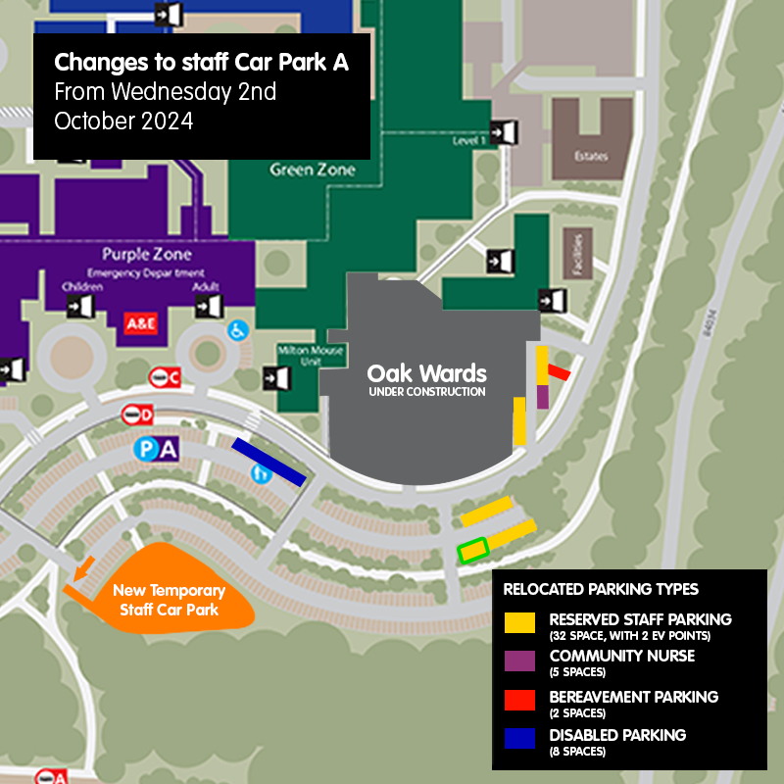There are two allocated spaces for the Bereavement Service (Green and White signage).

Please refer to the map for your directions.

***If you are coming for a viewing, please park as above and stay in your car and we will meet you. We will confirm this when booking a viewing time, especially if you are coming by taxi.***

**What do I need to do?**

In the first instance please contact the Bereavement Service – 01908 996 155 / 01908 996 154 and leave a message. We will return your call to discuss the next steps.

**Bereavement Manager**: Sue Ferrara

**Bereavement Officer**: Tina John

**Medical Examiner Officer**: Nurul Amin

**Medical Examiner Officer**: Caroline Loxton

When a person dies in hospital a Medical Certificate of Cause of Death (MCCD) will be issued, provided there is no Coroner involvement. This Medical Certificate is not the official Death Certificate, but you will need it to register the death.

One of the team of doctors that cared for your loved one will write the MCCD, which will then be checked and signed by the Medical Examiner. The Medical Examiner’s Office will call the Next of Kin to discuss the cause of death and to ask if they have any concerns about care and treatment of their relative. The Medical certificate will only be issued once this has taken place.

**The role of the Medical Examiner**

*“The aim of the Medical Examiner is to provide an enhanced degree of independence and objectivity in the scrutiny of in hospital-deaths within the Trust, whilst improving death certification, referrals to the Coroner, and discussion of causes of death with relatives.”*

**The National Quality Boards learning from Death guidance.**

# How to register a death

The Bereavement Service will contact you to explain the process of registration. We fully understand that you may wish to get started with your arrangements and will support you to do this whilst following the process that the law requires.

**Office numbers:** 01908 996 155 or 01908 996 154

If you leave a message we will respond as quickly as we can.

You may use our email: **bereavementservice@mkuh.nhs.uk**

**The office is open: 8am to 4pm** **Monday** to **Friday** (excluding bank holiday or weekends)

Once the Medical Certificate of Cause of Death has been agreed and issued it will be scanned over to the Register Office. We will need the name, telephone number and e-mail address (if you have one) for the relative who will register the death.

Once the Register Office have checked the certificate, an automated e-mail will be sent to the named relative to book an appointment to register the death.

Once the appointment is booked a confirmation e-mail will be sent which has a pre-registration form attached. The pre-registration form asks for the following information about the person who has died:

* Date and place of birth
* Home address
* Occupation (If married or a widow, the full name and occupation of their spouse)
* If the person was married, the date of birth of their spouse

If the Bereavement Service did not provide an e-mail address for the relative, the booking can still be made by calling 01908 372 101. The contact centre can check they have the documents required and book the registration appointment for you.

Once the death has been registered in person, the registrar will issue the following:

**The formal death certificate.** A charge is made forthis and each copy you require. The number of copies you require depends on the size of the estate, (you will need one for banks, insurance policies, investments, probate, or letters of administration) these are currently £12.50 each and will be given to you at your appointment.

**A green certificate for burial or cremation.** This will be scanned by the Registrar to your Funeral Directors to allow the funeral to take place. The deceased cannot be moved from the hospital until the green form has been provided. The green form is free of charge.

The Register Office now offers a “Tell Us Once” service. This cancels local authority departments, pensions etc and reduces the number of phone calls you will have to make.

The Bereavement Service will send you the following documents:

* Mail cancelling card from The Bereavement Register
* Hospital release form which you hand or e-mail to your chosen Funeral Director
* Bereavement letter from our Risk and Clinical Governance team, which also contains the contact details for the PALS service.

Arrangements for collecting property should be made directly with the ward that your loved one was admitted to.

Please be aware that wedding rings and similar items will be left in place until the deceased is taken to the Funeral Directors of your choice.

# Organ and tissue donation

The organ donation law changed in England in May 2020 to an ‘opt out system’. This means that if you are not in an excluded group and have not confirmed whether you want to be an organ or tissue donor (either by recording a decision on the NHS Organ Donor Register, or by speaking to friends and family) it will be considered that you agree to donate your organs and tissues when you die.

You still have a choice about whether you wish for your relative to become a donor, and your faith, beliefs and culture will continue to be respected.

For further information on the opt out system you can phone 0300 303 2094.

For further information about organ and tissue donation visit: [www.organdonation.nhs.uk](https://gbr01.safelinks.protection.outlook.com/?url=http%3A%2F%2Fwww.organdonation.nhs.uk%2F&data=05%7C01%7CCommunications%40mkuh.nhs.uk%7Caacbcf3bfe8b485ef6e108db8861fb8d%7Ce96dd0a15d474a949e4a5c1056daa82c%7C0%7C0%7C638253726920858929%7CUnknown%7CTWFpbGZsb3d8eyJWIjoiMC4wLjAwMDAiLCJQIjoiV2luMzIiLCJBTiI6Ik1haWwiLCJXVCI6Mn0%3D%7C3000%7C%7C%7C&sdata=gLesvNBHnr4Y%2BsI%2BoD3qbLJgzBisHeoZnFXW4W1yuo8%3D&reserved=0)

**Viewing in the Mortuary Viewing Suite**

The mortuary provides post-mortem facilities and optimum storage for both hospital and community deaths.

If you would like to view your loved one in the hospital mortuary, please contact the Bereavement Service and we can arrange this for you. Please be aware that viewings are limited to weekdays only. On some occasions viewings are not possible, and you will be informed of this. If you would like a hospital chaplain to be present at your viewing, then please do ask.

Post-mortems, if required, are carried out usually within 48 hours, although bank holidays may cause delays. The Coroner’s Officers will confirm when they take place.

The mortuary staff care for every patient with respect and make arrangements for the deceased to be released from the hospital to the funeral directors, providing all documentation is completed.

# The Hospital Chaplains

The Hospital Chaplaincy offers pastoral, spiritual, and religious support for people of any faith, and those with a non-religious world view. You may simply appreciate having someone else to be with you for a while, or someone to talk to. You may like to arrange a blessing for your relative or feel you would be comforted by prayers being said with you. One of the chaplaincy team can usually be available.

If you have specific religious needs, you may prefer to have your own faith community leader with you. You can contact them directly or ask the Chaplain to try to do this for you. If you are not sure who to contact, the Chaplain can discuss with you who might be appropriate and can then make contact on your behalf. The Chaplaincy provides 24-hour support for patients, families, and staff.

The Chaplaincy can be contacted via the Bereavement service, or you may telephone the direct line 01908 996 061. Please leave a message on the answer phone if the Chaplain is not available. Out-of-hours contact can be made through the switchboard on 01908 660 033.

Holy books are also available from the Chaplaincy.

# The Coroner

It will be necessary for the Coroner to be informed if, for example, your relative or friend’s death is sudden, unexpected or they have had surgery recently. There are other reasons, but these are the most common. The Coroner is a qualified Lawyer who is responsible for inquiring into the circumstances of some deaths. You will be informed, as soon as possible, if the death must be reported to the Coroner as this will have a bearing on the arrangements you can make.

In these circumstances, the death cannot be registered, nor can the funeral take place, without the Coroner’s authorisation. However, even if the death has been reported to the Coroner, you should not delay in contacting a Funeral Director who will be able to explain the procedures to you and make the necessary arrangements for the funeral.

The Coroner’s Office will contact relatives and inform them of the process. If you have any queries about the procedures involved, the Coroner’s Office or the hospital Bereavement Service will be able to help you.

A Coroner can order a post-mortem examination without asking the relatives’ permission, although the relatives are informed. Depending on the cause of death, the Coroner may decide that no further investigation is needed. In these cases, the Coroner will complete the relevant paperworkand send it direct to the Register Office. You will be notified of this and can then arrange to register the death.

In some circumstances, the Coroner may decide that a full investigation into the death should be held. These investigations are known as inquests and are held in public. If an inquest is to be held the Coroner’s Office will explain the procedures involved and advise you when and where the hearing will be held.

Usually, the inquest is opened and adjourned in the first few days after the death and an interim certificate will be issued to your Funeral Director at this stage, to allow the funeral to take place. The inquest is normally concluded later, and the death cannot be registered until this process is completed.

# Hospital Post-Mortem

Request for Consent to Hospital Post-Mortem – when a Medical Certificate of cause of death and formal notice has already been issued.

If the cause of your relative or friend’s death is quite clear the doctor will have provided a **Medical Certificate of Cause of Death** and a **Formal Notice** that the Medical Certificate has been signed.

If the death was known to be caused by a natural illness but the doctors involved with your relative’s care wish to know more about the cause of death and study effects of treatment, they may ask you for permission (consent) to carry out a Post-Mortem examination.

# Consent

You will be asked for your consent to a Post-Mortem being conducted, and to confirm this officially, you will be asked to sign a consent form. We believe families should be given the opportunity to understand why a Post-Mortem is suggested, the process involved, and your rights in the decision making.

You can choose to limit the extent of the examination and you can find out more details about this and other issues about the Post-Mortem examination from a booklet produced by the Department of Health called ‘Guide to Post-Mortem’. This booklet explains in more detail:

* Limited Post-mortem examination
* Organs being taken or held for further examination
* Disposal of any tissue or organs taken
* Medical research and education.

# If you do not wish to give consent

It is entirely yourdecision whether you give consent for a Hospital Post-Mortem and if you decide not to, you can still register the death and hold a funeral in the normal way**.** Your decision will not affect either you or anyone else in the future.

**Further Information:**[www.doh.gov.uk/pmconsent](http://www.doh.gov.uk/pmconsent)

# Arranging the funeral and choosing a Funeral Director

You do not have to wait until you have registered the death before contacting a funeral director, but if there is a delay for the certificate for any reason the funeral may be delayed**.**

Funeral Directors (or Undertakers) offer advice and a choice of arrangements at varying prices. These can be quite costly affairs. Always ask to see a brochure and price list before you decide. It might be worth contacting more than one to compare prices. We have a list of local Directors which you can obtain from the Bereavement Service.

Some families wish to conduct their own funerals. To get more advice about arranging the funeral yourself contact [www.naturaldeath.org.uk](http://www.naturaldeath.org.uk/) or Tel: 08712 882 098.

The [www.direct.gov.uk](http://www.direct.gov.uk/) website is full of very useful information, on matters around after-death care.

**After the Funeral**

Settling the deceased person’s estate can be confusing, time consuming, and distressing.

If there is a Will these wishes should be carried out. You may need to use the services of a solicitor. However, Probate is possible to do yourself.

**“Tell us once”: A service provided at the Register Office**

When someone has died there are lots of things that need to be done at a time when you are least likely to want to do it.

The death needs to be registered with the Registrar and once registration is complete, several Government organisations must be contacted and given the same information. The Registrar will provide a letter containing a unique reference number and contact details to enable this to be done by phone or 24/7 online.

This service saves you having to repeat yourself with all the personal details and can be used up to 28 days after the death is registered.

The table below shows the departments that are included in the Tell Us Once service.

|  |  |
| --- | --- |
| **Local Council**   * Housing benefit office * Council tax benefit office * Council tax * Collection of payment for local services * Libraries * Electoral services * Blue badge * Adult services * Children’s services * Council housing | **Department for Work & Pensions**   * Pension, disability and carers service * Job Centre Plus * Overseas Health Team     **HM Revenue & Customs**   * Child benefit * Child tax credit & working tax credit * Personal taxation |
| **Identity and passport services** | **Driver and vehicle licensing agency** |
| **Ministry of Defence, Service Personnel and Veterans Agency**  • War pension scheme | |

It is possible to report the death to these organisations and services if you decide not to use the service:

The information you give us will be treated securely and confidentially. The organisations who are contacted will use the information to update records, to end services, benefits and credits as appropriate, and to resolve any outstanding issues. They may use this information in other ways, but only as the law allows.

It will help if you have the following information with you, about the person who has died, when you use the service:

* Their National Insurance number and date of birth
* Details of any benefits or services they were receiving
* Their death certificate
* Their driving licence or driving licence number
* Their passport or passport number and town/country of birth

# Counselling and Advice

People react to a death in many ways. Some find it hard to talk about the experience, some find it helps. Some people feel guilty or even angry. Some work through their grief quicker than others. We all cope differently, and because of this you need to respect other people’s feelings and just be aware that it is their way of coping.

If you need help to come to terms with your sadness and feel that outside help may be of use, please see the contact list below for names and numbers.

# Looking after Yourself

The death of a family member or a friend can arouse emotional responses that you may not have experienced before. Here are a few suggestions that you may find helpful:

* Allow yourself time to rest, think and sleep
* Make time with family and friends
* Eat regularly
* Try to avoid making any major decisions too quickly
* Keep to a routine to help you get through one day at a time
* Schedule activities to get you through the worst times
* Accept your feelings as normal
* Vent your feelings (talking, crying, writing, physical exercise, listening to music, compiling an album or box of memories)
* Most importantly be patient, kind and gentle with yourself

# Members of your caring team who are here to help you

|  |  |
| --- | --- |
| Sue Ferrara | 01908 996 155 |
| Tina John | 01908 996 154 |
| Chaplaincy | 01908 996 061 |
| Nurul Amin | 01908 996 292 |
| Caroline Loxton | 01908 995 521 |

**If you need to speak to someone urgently you can ring the hospital switchboard on** 01908 660033 **and ask for the Chaplaincy team to be bleeped.**

|  |  |
| --- | --- |
| The Good Grief Trust (National Bereavement Partnership helpline) | 0800 448 0800 |
| Samaritans | 116123 |
| Child Bereavement Charity | 01908 550 895 / 08000  288 840 |
| Lesbian & Gay Bereavement project | 0208 2000 511 |
| Cruse helpline | 0808 8081677 |
| RoadPeace | 0845 450 0355 |
| Silverline | 0800 4 708090 |
| MK Bereaved Parents Group | 079177 43816 |

# To do list

This is a guide; it is not definitive.

|  |  |  |
| --- | --- | --- |
| **Organisation** | **Contact details** | **Notified** |
| Executer of will / Solicitor |  |  |
| Probate | Gov.uk website |  |
| *State pension and benefits  Private pension | 0345 606 0265 |  |
| Insurance company |  |  |
| Bank/Building Society |  |  |
| Mortgage provider, housing association  *Council housing office |  |  |
| *HM Revenue and Customs  tax office |  |  |
| School, college  Workplace, Trade union |  |  |
| Utility providers  Gas  Electricity  Water board  Telephone  TV/Internet |  |  |
| Post office |  |  |
| Car insurance |  |  |
| *DVLA |  |  |
| *Passport Office |  |  |
| Social Services Job Centre |  |  |
| Doctor |  |  |
| Sporting/social clubs |  |  |

*Denotes services that are included in the Tell Us Once service

**Feedback**

Following this time of sadness, we invite any comments regarding your relative’s end-of-life care so that we can learn and develop our services. Please use the Freepost address below to share your thoughts.

If you could tell us the ward area and name of your relative that would be helpful, but this information is not essential.

* Attention of Sue Ferrara, Bereavement Manager
* Freepost RLXB-TUUR-JCLS
* Milton Keynes University Hospital NHS Foundation Trust,
* Standing Way, Eaglestone
* Milton Keynes
* MK6 5LD

Please note that although Milton Keynes University Hospital NHS Foundation Trust may include links to external websites, the Trust is not responsible for the accuracy or content therein.



**We ask for information about you so that you can receive proper care and treatment. This information remains confidential and is stored securely by the Trust in accordance with the provisions of the Data Protection Act 2018/GDPR. Further guidance can be found within our**

**privacy notice found on our Trust website:** [**www.mkuh.nhs.uk**](http://www.mkuh.nhs.uk/)

**Milton Keynes University Hospital NHS Foundation Trust Standing Way, Eaglestone, Milton Keynes, MK6 5LD**

**©Milton Keynes University Hospital NHS Foundation Trust**

**Author:** Bereavement Manager

**Date published: 07/2021**

**Date of review: 09/24**

**Version No:** ORG/PI/5/V8