Meet the Maternity Team
Information Leaflet

Welcome to the maternity department

Whilst you are in the maternity department, you may see many different members of staff. If you're not sure who they are please ask them to explain. All staff should be wearing name badges with the trust logo. If you can't see the badge, you can ask them to show it to you. Staff may also be wearing lanyards that identify their role.

Here is our guide to who you may meet:

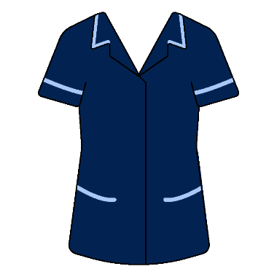
Senior Midwife
Our wards are managed by a senior sister, who can be identified by their uniform. They work as part of a team leading and managing the ward to ensure the highest standards of midwifery and obstetric-led care is provided to meet the requirements of women and their families at all times. They will expect to see that all women, visitors and staff are treated with the utmost courtesy, dignity and respect. You can ask to see the senior sister if you have any concerns.

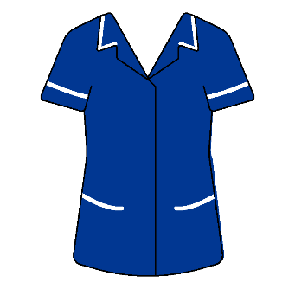
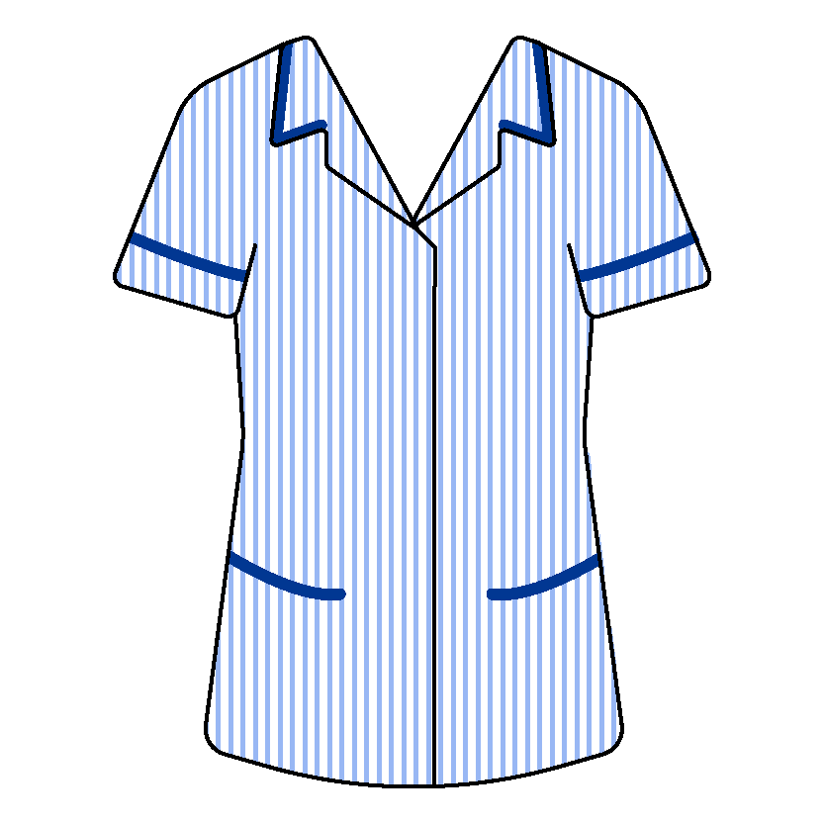
Midwives
You will have a qualified Midwife who is responsible for your care. They will introduce themselves to you when you arrive or at the beginning of a change of shift. It is part of their clinical practice to provide you with safe, quality, patient focused care, and to make sure there is timely assessment of your needs, continuing care and treatment.

Student Midwives
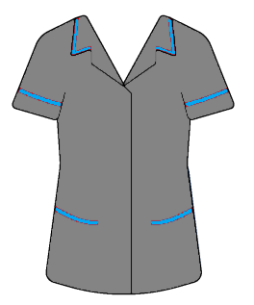
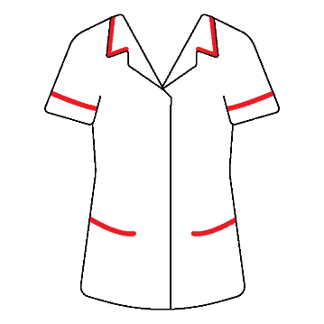
They are on a structured training programme affiliated with a university for three years. You may see University of Northampton or Bedfordshire student Midwives who wear either a grey tunic with blue piping or a white tunic with red. They work under the guidance of your Midwife. Around half of the students’ training is carried out at university and half in the clinical environment.

Doctors
Doctors normally wear their own clothes or hospital scrubs and can be identified by their name badge and hospital ID badge.

We have three types of doctors:
- Obstetricians - these are doctors who mainly deal with the management of pregnancy and childbirth.
- Paediatricians - who specialise in the diagnosis, care, and treatment of babies.
- Anaesthetists - are specialist doctors who are responsible for providing anaesthesia to patients for operations and procedures.

You may be seen by a number of doctors during your hospital stay, these could include: the Consultant (Specialist), the Registrar and the SHO (junior doctor). Together they assess and manage your medical care. You may also be seen by student doctors who work under the supervision of the senior doctors.

The SHO is typically the doctor you will see most often. The Registrar is the ward’s senior doctor who supervises the SHO and they both work between all of the Maternity areas. The senior Consultant (or Specialist) attends to see specific patients under their care.

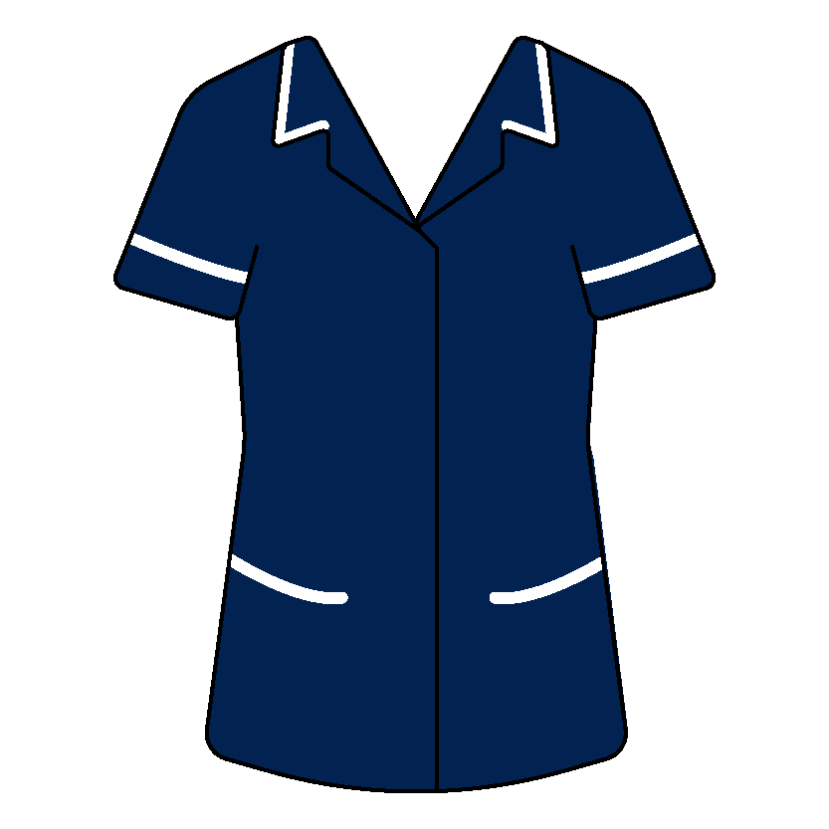
Advanced Neonatal Nurse Practitioner (ANNP)
ANNPs are highly skilled members of the paediatric team. They wear navy tunics with white piping and work alongside the paediatric doctors on the ward. They review babies, make individualised care plans, and provide specialised clinical care at an advanced level to neonates and their families. As part of their role, they may also perform the examination of the Newborn screening check (NIPE) that all babies are required to have before 72 hours of age.
Maternity Care Assistants (MCAs)
The MCAs wear a grey striped dress or tunic and work under the supervision of the Midwife. They are here to help get you moving, washing, and dressing. They help with serving patient meals, making beds, and assisting with your overall comfort. They will also monitor your wellbeing by taking your temperature, pulse, blood pressure and monitoring your breathing. They will report any concerns back to the Midwife looking after you.

Nursery Nurses
The Nursery Nurses wear a pink-striped tunic and work under the guidance of the Midwives. They take responsibility for the nursing care of babies when required. This includes monitoring temperature, pulse, respiration, oxygen saturation, weight and performing certain blood tests. They work with the Midwife looking after you and will let the Midwife know if there is anything they are concerned about. They offer feeding support where necessary. An important aspect of their role is to give advice, guidance and support to parents.
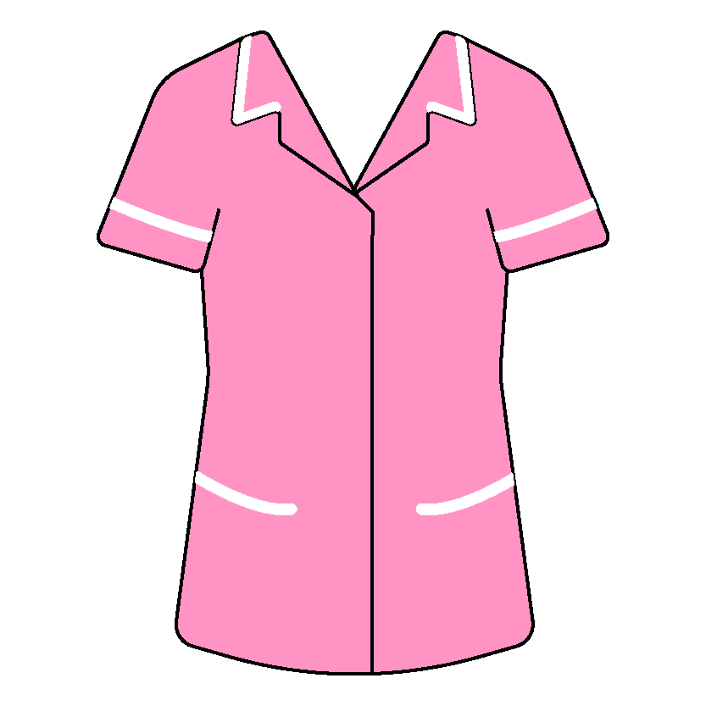
Newborn Hearing Screeners
They come to the ward to complete your baby’s Newborn hearing screening and are hard to miss as they wear a bright pink tunic. They are a specialist team that offer hearing screening to all babies once they are at least six hours old.

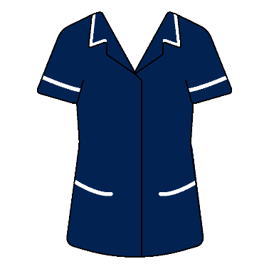
Specialist Midwife
A senior Midwife with a special interest in a particular area, e.g. infant feeding or practice development. They are available to provide additional support to both midwives and women/birthing people. They can be found wearing a navy dress or tunic with light blue trim.
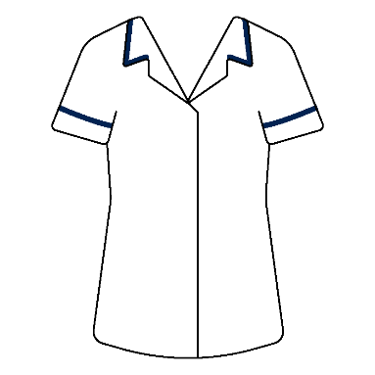
Physiotherapists
They are here to help and treat women after they have had their baby. They come to the ward daily to discuss the health and well-being of women. They identify and maximise their recovery through health promotion, preventive healthcare, treatment and rehabilitation.

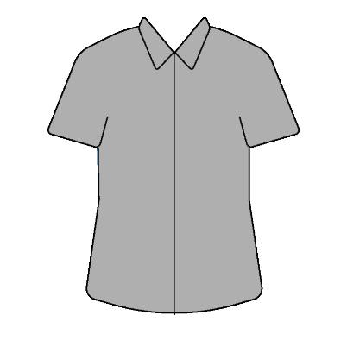
Housekeepers
The housekeeper wears a dark grey blouse and helps with the everyday running of the ward for the benefit of patients and their visitors. They are an important part of the ward team and support the delivery of clinical care by ensuring the ward is a clean, safe, and attractive place. Housekeepers coordinate a range of services including catering, cleaning, maintaining the environment and equipment and ordering resources for the ward.

Ward Clerks
The ward clerks wear a lilac blouse and will greet you and your visitors when you come onto the ward. Their role includes answering the secure door entry system, sorting and filing patient notes, compiling patient leaflets, and managing the ward reception desks.

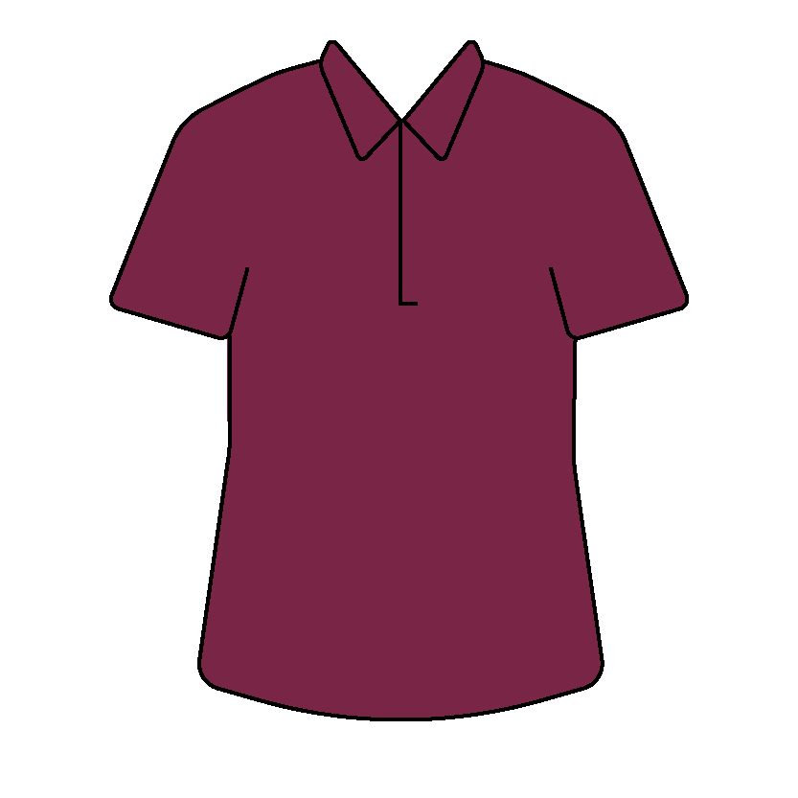
Domestics
They are part of the ward team, and they have a very important role in making sure that all areas are clean and safe. They do routine cleaning tasks which need to be done on a daily or weekly basis, this could include dusting, cleaning hard floors with mops or electric floor cleaners, cleaning toilet and bathroom areas, emptying waste bins, as well as responding to emergency spills.

Peer Supporters
Peer Supporters are volunteers, who are mothers themselves that have breastfed their own children and are here to give basic support to new mums. They are a friendly face on the ward and have trustworthy and accurate infant feeding information. They have been specifically trained by our Infant Feeding Midwife. They normally wear a pink polo shirt or their own clothes and will always have a name badge on so they can be easily identified.

Volunteers
They will be in their own clothes with a name badge and volunteer badge. They are on the ward to help with bed making, serving meals, fetching water etc., and are a hugely valuable part of our team.
Other staff you may see on the ward are part of the senior leadership team

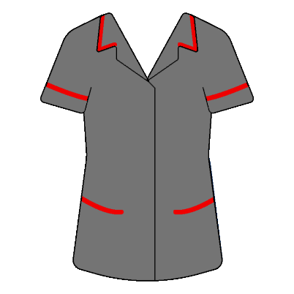
Matrons
The Ward Matron is a senior member of staff who is responsible for the ward and ensuring excellent patient experience and safety. They support the senior sisters. They manage improvement of the patient experience and maintenance of public areas of the ward. In order to do this, our Matron has forged links with other professionals and departments. These include estates, facilities, infection control and patient/service user groups.

Consultant Midwife
Our Consultant Midwife role is one that provides leadership and education to other members of staff. They offer support and advocate for women in their birth choices. Together we will make sure that you are empowered to make an informed choice about your care.

Governance and Quality Lead
The governance lead ensures the hospital policies and guidelines are up-to-date and in line with the best available evidence to ensure the care provided is of the highest standard. They also oversee investigations, highlight areas for improvement and contribute to change in practice to improve care.
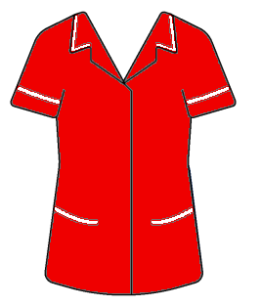
Head of Midwifery
They are responsible for the delivery of Midwifery services. Their role covers all clinical areas within their Division (Maternity and Paediatrics), and they have a particular focus on quality, patient experience, strategy, governance, performance, and development of the workforce.

We ask for information about you so that you can receive proper care and treatment. This information remains confidential and is stored securely by the Trust in accordance with the provisions of the Data Protection Act 2018/GDPR. Further guidance can be found within our privacy notice found on our Trust website: www.mkuh.nhs.uk

Author: Lauren Mitchell
Date Published: 02/2022
Date of review: 02/2024
Version: 2
Document ID: MIDW/PI/75
Milton Keynes University Hospital NHS Foundation Trust
Standing Way
Eaglestone
Milton Keynes, MK6 5LD

©Milton Keynes University Hospital NHS Foundation Trust
www.mkuh.nhs.uk

