Milton Keynes University Hospital NHS Foundation Trust
Gender Pay Gap Report as at 31 March 2020

- Gender Profile (Male – Female)

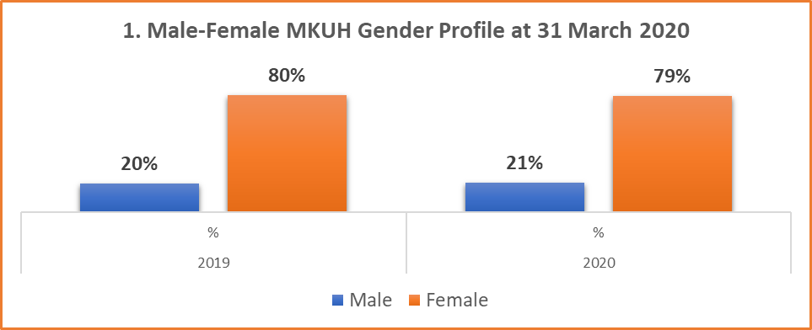

The male – female gender profile of the Trust at 31 March 2020 is 21% (771) male and 79% (2987) female.

- Average (mean) and median hourly rates

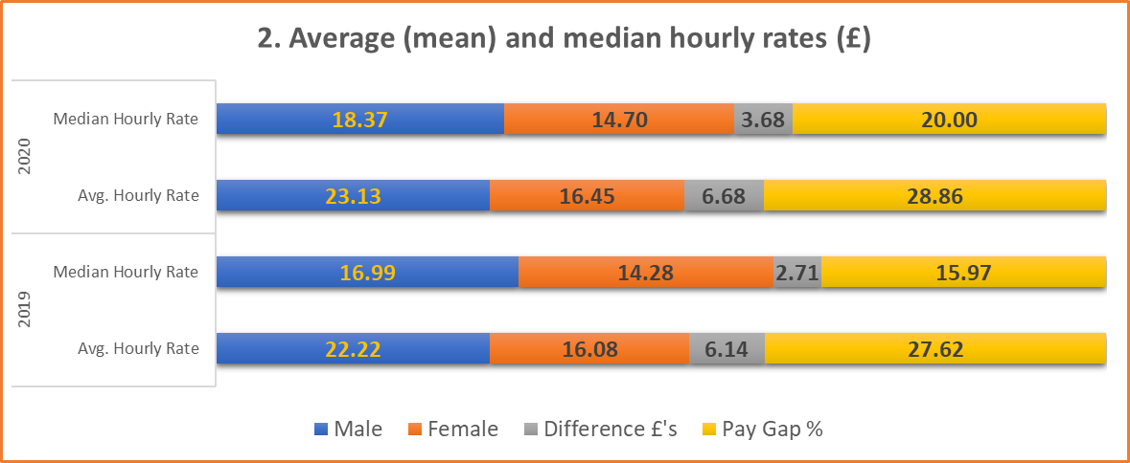

  - The average (mean) hourly rate of pay is calculated from a specific pay period, 31 March 2020. The hourly rate is calculated for each employee based on ‘ordinary pay’ which includes basic pay, allowances and shift premium pay.

  - The median hourly rate of pay is also calculated from the same specific pay period, 31 March 2020. The median rate is calculated by selecting the average hourly rate at mid-point for each gender group.

  - The percentage variance for the average hourly rate of pay is 28.9%. This calculation is based on the average hourly rate of pay of 2987 female staff compared to 771 male staff. Since the average is calculated over a wider distribution of staff (almost 4 times more female than male staff), some degree of variance is to be expected.

  - The percentage variance for the median hourly rate of pay is 20%. For MKUH statistically this is more indicative than the hourly rate of pay as it is not impacted as much by the female to male ratio. Consideration to the variety of roles within the Trust will need to be given when reviewing the variance.

  - Agenda for Change (AfC), other NHS pay grade structures and Terms and Conditions of Service are negotiated at national level. Progression (where applicable) through pay increments is applied in line with national policy for all staff. When calculated in this manner, the gender pay gap should be negligible and gaps may therefore be attributed to factors highlighted within the conclusions of this report.

- Average (mean) and median bonus payments

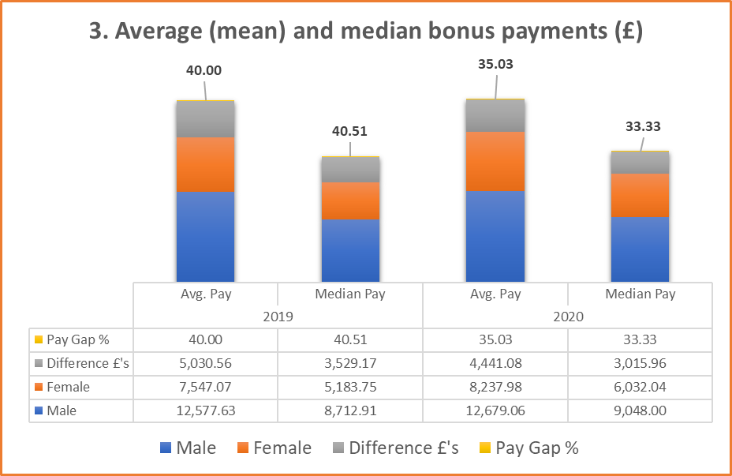

  - As an NHS Trust the pay elements that fall under the bonus pay criteria comprise annually negotiated and awarded local Clinical Excellence Awards (or Discretionary points for Specialty and Associate Specialist Grades) and are only applicable to certain groups of Medical and Dental Staff.

  - Average bonus pay is calculated from the total bonus pay period received in the 2020 financial year (01 April 2019 to 31 March 2020). The median values are based on the mid-point of all staff receiving bonus pay by each gender group.

  - The percentage variance for the bonus hourly rate of pay is 35.0% while the percentage variance for the median bonus hourly rate of pay is 33.3%. The pay elements used in this calculation are awarded as a result of recognition of excellent practice, innovation and/or medical research over and above contractual or service delivery requirements. The selection criteria by which applications are assessed during the pre-panel award process is considered fair and equitable with personal information hidden until allocation of points (and awards) has taken place for each application.

- Proportion of male and female receiving a bonus payment

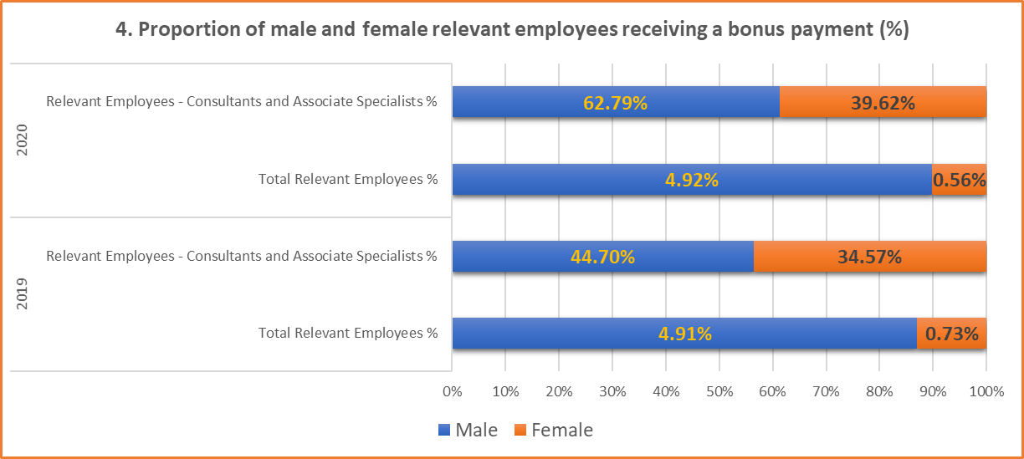

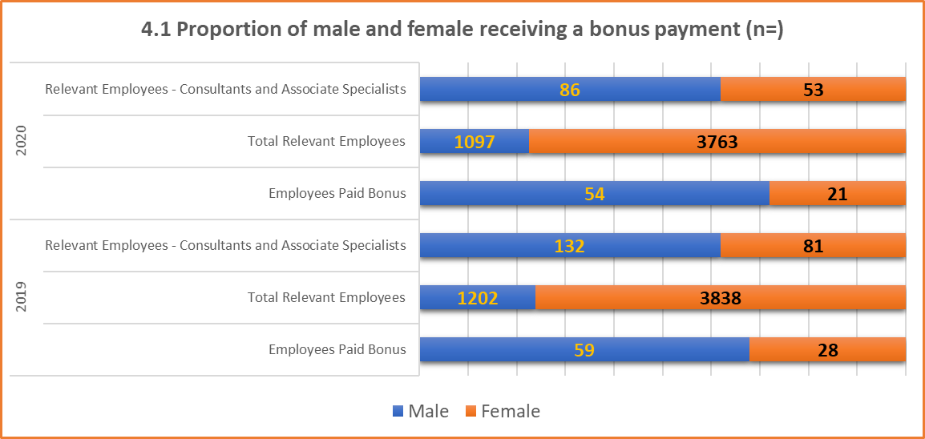

  - This calculation expresses the number of staff receiving bonus pay as a percentage of the total number of staff. It further expresses these as a percentage of the number of relevant employees who could be eligible for a bonus payment in each gender group.

  - The pay elements that fall within the eligibility for bonus pay criteria are annually awarded local Clinical Excellence Awards which are only applicable to certain groups of Medical and Dental Staff.

  - Bonus pay applies to just over 1.5% of all staff employed by MKUH. The gender split for this group of Medical and Dental staff is broadly replicated on a national scale. Whilst these data are of relevance to MKUH, they are less significant than the gap shown for average and median rates. The Trust however recognises that it can take steps locally to redress this imbalance by supporting appointments to underrepresented specialties.

  - A total of 54% of 139 relevant employees received a bonus. Of the total relevant number of employees who were paid a bonus, 15.1% (n=21) are female and 38.8% (n=54) are male.

- Proportion of male and female in each pay quartile (Ordinary Pay)

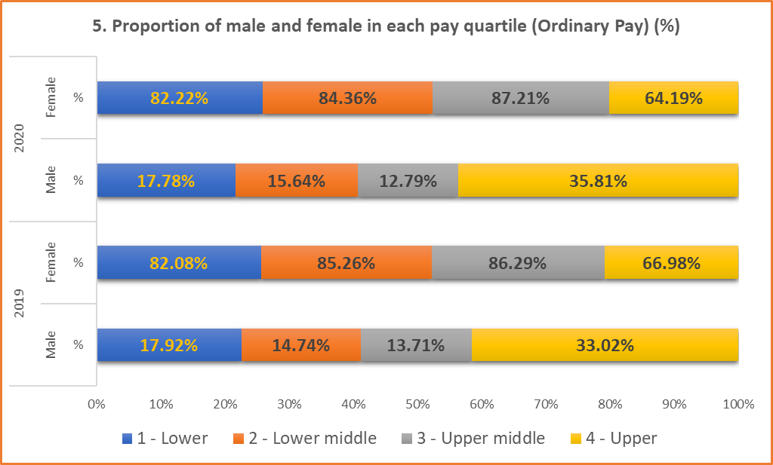
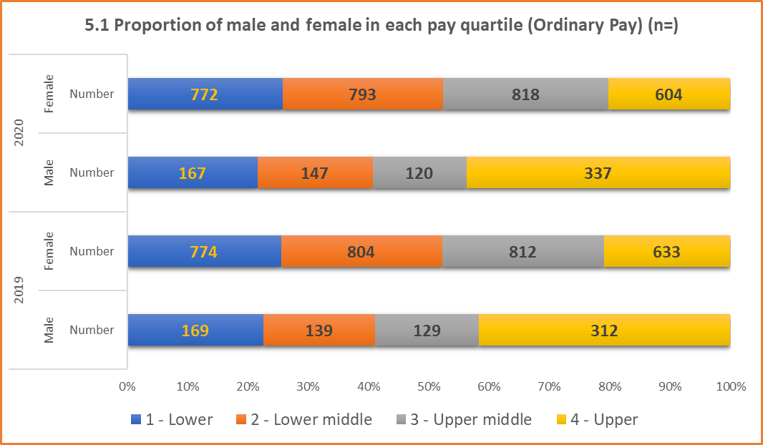

  - To create the quartile information, all staff are sorted by their hourly rate of pay. This list is then split into 4 equal parts where possible.

    - Quartile 1 – Lower: Includes all employees whose standard hourly rate places them at or below the lower quartile.

    - Quartile 2 – Lower middle: Includes all employees whose standard hourly rate places them above the lower quartile but at or below the median quartile.

    - Quartile 3 – Upper middle: Includes all employees whose standard hourly rate places them above the median quartile but at or below the upper quartile.

    - Quartile 4 – Upper: Includes all employees whose standard hourly rate places them above the upper quartile.

  - The total staff analysed comprises a headcount of 3758 MKUH employees as at 31 March 2020.

  - When reviewing the quartile information, account should be taken of the variety and types of roles available within the organisation and the gender distribution within specific roles.

  - The highest variances for quartiles for the Trust overall is found within the lower and upper quartiles.

  - There is a higher proportion of female staff in quartiles 1, 2 and 3. Included within this group are Administration and Clerical staff, Ancillary Staff, Allied Health Professions, Nursing and Midwifery and Professional and Technical Staff Groups. A higher proportion of staff within these groups are female.

  - Quartile 1 is 82.2% female and 17.8% male and is largely unchanged from 2019 (female – 82.1%, male – 17.9%). This remains broadly representative of the overall Trust gender profile.

  - The upper quartile (Q4) at 35.8% has a higher proportion of male staff and is a slight increase from 2019 (33.0%). The variance in this quartile is generally attributable to the significant gender differential amongst Medical staff and senior leadership/managerial roles within the Trust. This is countered by a higher proportion of female staff within the Scientific, Nursing and Midwifery staff groups.

- Conclusions and Recommendations
  - To build upon work already commenced to gain understanding of the reasons for the reported gender pay gap the Trust will continue to encourage participation and uptake of the ‘P2P Listening Service’, engagement with MKUH Staff Equality Networks.

  - Monitor:

    - Recruitment and Selection
    - Progression and Talent Management
    - Uptake and impact of Flexible Working
    - Monitoring of Reward and Bonus Awards / allocations
    - Workforce Race Equality Standard (WRES) results
    - Medical Workforce Race Equality Standard (MWRES) – due for implementation 2021-2022
    - Workforce Disability Equality Standard (WDES) results

  - The Trust will identify areas for focus internally and externally through e.g. Women in Technology and development of Divisional level Action plans

  - Encouraging female career progression through coaching and mentoring and Positive Action initiatives

  - Continued support and development of Staff Equality Networks:

    - Black, Asian and Minority Ethnic
    - Staff Ability
    - Faith and Belief
    - Pride @MKUH
    - Women’s Network

  - Review Flexible Working Policies and Employee Passports to explore and offer a range of flexible working options of benefit to female colleagues. This will enable pay gaps to close through continuity of paid employment.

  - Reporting on Gender and wider Equality and Diversity data

  - Continue to offer internal and external senior management and leadership development programmes for all managers and monitor their uptake by protected characteristics.

  - Provide oversight and assurance of delivery of the Trust’s Equality, Diversity and Inclusion agenda through the Workforce Strategy, Workforce Board and to the Trust Board as delegated through the Workforce and Development Assurance Committee

At Milton Keynes University Hospital NHS Foundation Trust, we will actively participate in opportunities that support our commitment to building an inclusive culture enabling us to improve equality, diversity and inclusion at all levels.
I confirm that the information contained within this report is accurate.

Joe Harrison
Chief Executive

