Diabetes Department
Patient information leaflet (PIL)

Information for people with diabetes on insulin pump therapy
Insulin Pump Advanced Bolus Options

(for 16 years and above)

Author Panagiotis Siekkeris (Diabetes Specialist Nurse)
Imelda Robson (Diabetes Specialist Practitioner).

*Adapted version from the Northamptonshire Healthcare NHS Foundation Trust “Insulin Pump Advanced Bolus Options” Patient Information Leaflet (PIL).

Published December 2020
Review December 2022

Introduction
This leaflet has been designed to provide you with information to help you understanding and applying the advanced bolus options in your insulin pump.

When you use an insulin pump, the insulin given to cover food is called an insulin bolus. Different foods and meals have different effects on your blood glucose levels. Altering the timing and type of bolus to match the food eaten can help to keep post-meal blood glucose levels under control.
Evidence suggests that those who use the pumps advanced bolus options, such as dualwaves, multiwaves or combo boluses, can achieve better control of their diabetes. The terminology varies depending on the model of the pump that you use. This information is designed to help you choose your bolus type and make the most of your insulin pump.
Use of advanced bolus options are not recommended when you are wearing a sensor augmented insulin pump that automatically adjust your hourly basal rates or corrections.

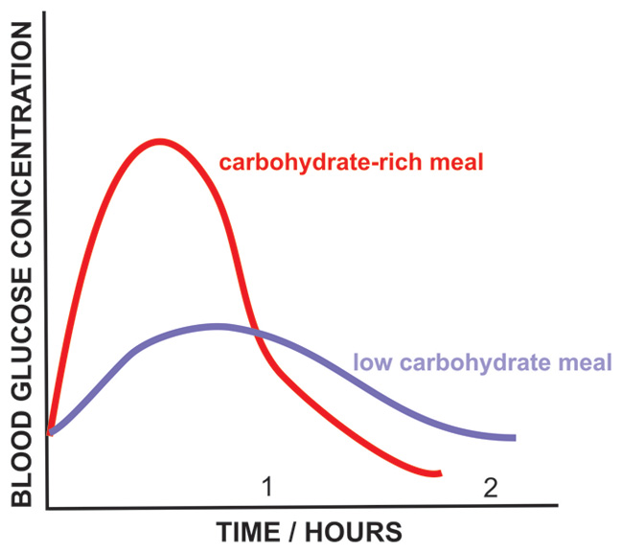
Glycaemic Index
The glycaemic index (GI) is a guide to how carbohydrate foods affect your blood glucose levels. The GI of glucose is 100 as it is absorbed rapidly. A high GI food (more than 70) increases the blood glucose levels quickly for a shorter amount of time, whereas low GI food (less than 55) results in a slower and more prolonged rise in blood glucose levels, therefore two meals the same carbohydrate content can affect your blood glucose levels differently depending on their glycaemic index.

A normal or standard bolus, like an insulin injection, may not be appropriate for all meals. You may have noticed that giving a normal or standard bolus with a low GI and/or high fat food, such as pizza or pasta, results in a low blood glucose level (hypoglycaemia) soon after eating followed by a subsequent rise in blood glucose level. This is due to the slow release of the carbohydrate in comparison to insulin action. Very high GI foods may also be difficult to manage, for example a high GI breakfast may result in an initial rise in blood glucose levels followed by a low blood glucose levels as the insulin action lasts longer than the release of carbohydrate into the blood stream. The table below shows the glycaemic index of commonly eaten foods.

The glycaemic index is calculated based on a set amount (50g carbohydrate) of an individual food, however the amount you eat, and combination of food is likely to vary, which will change how the meal affects your blood glucose levels.

Other factors that affect the blood glucose response to meals include:
- Fat and protein- the presence of fat (fried foods, oil, butter, cream, cheese) and protein (meat, fish, and eggs) as part of a meal will slow down the rate of digestion meaning the glucose is released more slowly into the bloodstream. Fat may also increase the resistance to insulin.
- Fibre- higher fibre foods such as granary breads, wholegrain or bran cereals, fruits, vegetables, beans, pulses, and potato skins are digested and released more slowly resulting in a slower rise in your blood glucose levels.
- Meal size- a larger amount of any type of carbohydrate will take longer to digest than a smaller amount; this is sometimes referred to as the glycaemic load (glycaemic index multiplied by the grams of the carbohydrate). You may therefore find meals above a certain size require the use of a dualwave, multiwave or combo bolus. You may find an amount of carbohydrate that is large for you. It is likely to vary from person to person; a starting point is more than 1.5g carbohydrate per kilogram of body weight. For example, if you weigh 50Kg, try a dual wave or combo bolus for 75g carbohydrate or more.
- Type of starch- different types of starch have different chemical structures and are therefore digested and absorbed at different speeds. Therefore, pasta has a lower GI compared to rice.
- Processing- For example, easy cook rice has a high GI than basmati rice and whole jumbo oats has a lower GI than rolled oats. Different brands of the same cereal, such as cornflakes, can have different GI’s due to different processing methods.
- Cooking methods- for example, a machined potato has a higher GI than a boiled new potato or chip due to the level of processing and addition of extra fat).
- Ripeness- For example, a roper banana will have a high GI than an unripe banana as the starch naturally breaks down into sugars and is digested and absorbed more quickly.
- Individual variation- difference individuals respond different to the same foods.

Choosing your bolus types

Normal to Standard bolus- this type of bolus works with small snacks and high glycaemic index foods. If you are not sure how much you are going to eat give half of the insulin at the beginning of a meal and the remainder at the end, the total amount should match the total amount of carbohydrate eaten. Remember- you should always have some insulin before you eat. Bolusing 15-30mins in advance of eating may help to manage blood glucose levels after very high GI foods.

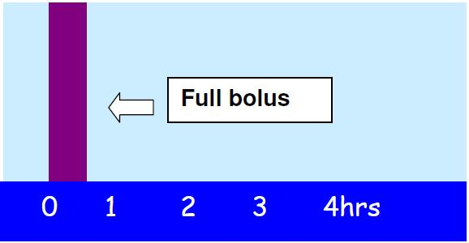

Dualwave or multiwave or combo bolus-this type of bolus is recommended to help you achieve the best possible post meal blood glucose levels. It is a combination of the normal/standard and extended/squared bolus. Some of the insulin is delivered at the start of a meal; the remainder is given as an extended bolus. You can decide how much insulin is given immediately and how much is given as an extended bolus and for how long.
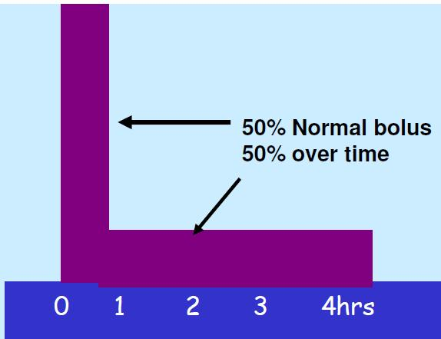
Extended or square wave bolus- the bolus delivery is extended over a longer period. Most foods will require a certain amount of insulin to be given initially; therefore, you should always use a dualwave, multwave or combo bolus. Only use the extended or squarewave bolus if you have been recommended to do so by your Diabetes team for a specific situation.

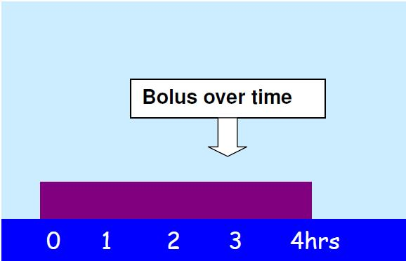

When should I use a Dualwave or multiwave or combo bolus?
Use the table below to help make choices about your bolus type, if you have found a normal bolus unsuccessful in managing your blood glucose levels. Continue to count the carbohydrates you are eating and use your insulin: carbohydrate ratio to work out your total insulin dose, then choose the bolus type and adjust the timing according to the type of meal you are eating. This is just a guide to get you started; each individual is likely to respond differently. If a normal bolus is working, there is no need to change the bolus. If the bolus does not work initially, make some adjustments to duration, or split and try again until you have worked out a suitable method. Keep a note of what has worked for specific meals.

Find some meal examples to try on the table below.

Meal/ Snack | Example | Amount of Carbohydrate | When to start delivery | Dualwave or multiwave or extended bolus
Low fat mixed meal with high GI carbs, larger meals | Fish fingers, mash and peas or chicken, easy-cook rice, and vegetables | Large amount of carbs | Before eating | Try 70% : 30% or 50% : 50% over 60 – 90 minutes
High Fat, high GI mixed meal | Cheese on toast, roast dinner | Any | Before eating | Try 70% : 30% or 50% : 50% over 1-3 hours
Low GI mixed meal | Pasta with tomato sauce | Any | Before eating | Try 30%:70% or 50% : 50% over 1-3 hours
High fat low GI mixed meal | Pasta with cheese sauce, pizza, fish, and chips, Chinese or Indian take away | Any | Before eating | Try 30% : 70% or 50% : 50% over 4-8 hours

What do I do if I decide to have more food, such as pudding or snack, while the bolus is still running?
- You can deliver a normal or standard bolus for extra foods while a dualwave or multiwave or combo bolus is running, although this is not recommended if you are testing the bolus.
- The bolus can be stopped if necessary, each type of pump works slightly differently, therefore make sure you know how to stop the bolus should you need to.
How do I know if the bolus is working?
- To check if the bolus type is working you will need to check your blood glucose levels after eating.
- For a normal or standard bolus, check your blood glucose levels 2-3 hours after eating.
- For a dualwave or multiwave or combo bolus, check your blood glucose levels hourly for the duration of the bolus. For example, if you have extended your bolus for 3 hours, check your blood glucose levels before eating, then at 1, 2, 3 hours after eating. You can then decide if the chosen bolus has worked well for the food eaten or if you need to try something different next time. If you use sensors, they may also help you to test the bolus.
- Remember, if you have been very active, have eaten low GI foods earlier in the day or if you are unwell it is likely to be difficult to test whether the advanced boluses are working.

