Tell us about your care:

Compliments
Comments
Concerns
Complaints
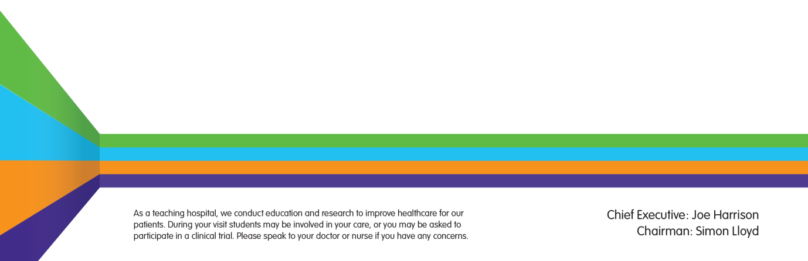

Welcome
At Milton Keynes University Hospital NHS Foundation Trust we aim to provide you with the best healthcare and treatment possible and we want to ensure that you have a positive experience. Your views are very important in helping us to get this right.

Compliments and comments
Most of our patients are pleased with their care and some may wish to pass on compliments and comments to staff. Staff are always delighted to hear your feedback.
You can add comments to the Friends and Family Test leaflet which are available in all areas. Compliments can also be sent directly to the appropriate ward/department or the PALS team at pals@mkuh.nhs.uk or directly to the Chief Executive at compliments@mkuh.nhs.uk.

Concerns and complaints
There can be times when you feel the service you are receiving requires improvement. We want to resolve any issues as soon as we can.
Please tell us about your concern or complaint as soon as possible.
Each ward and department has a Senior Sister, Charge Nurse or manager and they will work with you to try to resolve any concerns raised at the time. Each of these areas also has a dedicated Matron or departmental manager who can also help.
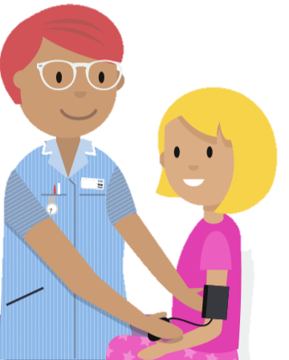

What if I am not comfortable or confident to say something at the time or if I would prefer to talk to someone who is not involved in my care?
If you do not wish to make a formal complaint but would still like to raise your concerns, the Patient Advice and Liaison Service (PALS) can help by supporting you to raise your concerns with the relevant staff. If you are the patient, or have the consent of the patient, the team will work alongside you and the responsible staff to resolve concerns as quickly as possible.
How can I contact PALS?
Telephone - 01908 995954
(If you reach the answer phone PLEASE LEAVE A MESSAGE and we will do our best to get back to you that day or the following working day)
To request a call back please text - 07773577923
E-mail - pals@mkuh.nhs.uk
In person
Monday to Friday: 9.30am-4pm (excluding Bank Holidays).
Our office is located in the hospital’s main entrance area.

What if PALS are not able to resolve my concern to my satisfaction?
The PALS team will be able to explain how to make a formal complaint by referring you to the Complaints team. The Complaints team will work with you to ensure that your complaint is formally investigated by the relevant staff. A response will be given in either a written response letter or by way of a formal meeting to discuss your complaint with appropriate staff.

What if I want to make a complaint immediately?
You can make a formal complaint by either writing to the Complaints team or the Chief Executive. Before writing think about what you would like to achieve from the complaints process. For example, do you want:
- An apology
- An explanation of what happened and why
- Changes and improvements
- To make staff aware of your concerns
- To prevent the same thing happening again
- The opportunity to meet with staff to discuss your concerns.
The hospital investigates all complaints within the agreed Local Authority Social Services and National Health Service Complaints (England) Regulations 2009.
Please try to include details of:
- Where and when the issue happened
- The exact issues you wish to be investigated including a description of what happened
- The name of the service or person you are complaining about
- The patient’s details and the complainant’s details, if different
- A contact telephone number

Write:
Complaints Team / Chief Executive, Milton Keynes University Hospital
Oak House
Standing Way
Eaglestone
Milton Keynes
MK6 5LD
Email:
complaints@mkuh.nhs.uk
Call:
The complaints team can be contacted on 01908 996260. The office is open 9am to 5pm from Monday to Friday, excluding Bank Holidays
The complaints team can support you to write your complaint following a discussion about your concerns.

Who can complain?
Anyone who is receiving, or has received, NHS treatment or services at MKUH.
If you would like a representative to make a complaint on your behalf, then we will need your written consent to proceed.
If the complaint is regarding:
- A patient who has died;
- A child; or
- A patient who is unable because of physical or mental incapacity to make the complaint themselves
then the Trust must be satisfied that the person making the complaint has the authority to do so on behalf of that patient.

Is there a time limit for making a complaint?
Normally, a complaint should be made within 12 months.
This is counted from the date when the incident you are complaining about happened, or the date when you became aware of the information which has led you to complain.
Where a complaint is made after 12 months, we may investigate if we think that:
- Having thought about all the circumstances, you had good reason for not making the complaint within the time period; e.g. severe distress or trauma.
- It is still possible to investigate the complaint effectively and efficiently.

What happens next?
It is our aim to deal with your complaint in agreement with you and to your satisfaction. We will try and answer all your concerns and respond to any areas for improvement and take appropriate action. This is known as ‘local resolution’.
We will let you know that we have received your complaint within three working days, either by calling you or writing to you.
When we receive your letter the complaints team will try to telephone you or meet you in person to discuss your complaint in greater detail. We will also agree a way forward with you on how the complaint should be dealt with.
This agreement will take into consideration how the complaint will be handled (i.e. an investigation by staff followed by a written response or a meeting with relevant staff, or both) and the timescales in which we hope to achieve this.

What if I need help to make my complaint?
If you need any help the seAp advocacy service will be glad to advise and support you. seAp adcocacy are able to give advice, information and support to complainants throughout the process.
seAp is one of the largest providers of advocacy services in the UK and England's largest provider of NHS Complaints Advocacy.
Independent support can be provided by the local seAp service who can be contacted on:
Telephone: 0330 440 9000 (charged at local rate)
Text: SEAP to 80800
E-mail: info@seap.org.uk
Online referrals: Spartan.seap.org.uk
Post: seAp Advocacy PO Box 275, Hastings, T34 9HU

What if ‘local resolution’ is unsuccessful?
If you are not happy with the way we have tried to resolve your complaint, you can ask the Parliamentary Health Service Ombudsman to review the matter.
The Parliamentary Health Service Ombudsman can be contacted as follows:
• Visiting the website
www.ombudsman.org.uk
• Call the complaints helpline
0345 015 4033
(Mon-Fri 8.30am-5.30pm)
• E-mail
phso.enquiries@ombudsman.org.uk
• Fax
0300 061 4000
• Write to:
The Parliamentary and Health Service Ombudsman
Millbank Tower
Millbank
London
SW1P 4QP

Milton Keynes University Hospital NHS Foundation Trust Standing Way
Eaglestone
Milton Keynes
MK6 5LD
©Milton Keynes University Hospital NHS Foundation Trust www.mkuh.nhs.uk
Author: Trust Lead for Complaints and PALS
Reviewed by: Julie Goodman
Reviewed: 02/2019
Review Date: 02/2021
Version No: ORG/PI/3/V9

We ask information about you so that you can receive proper care and treatment. This information remains confidential and is stored securely by the Trust in accordance with the provisions of the GDPR 2018.

