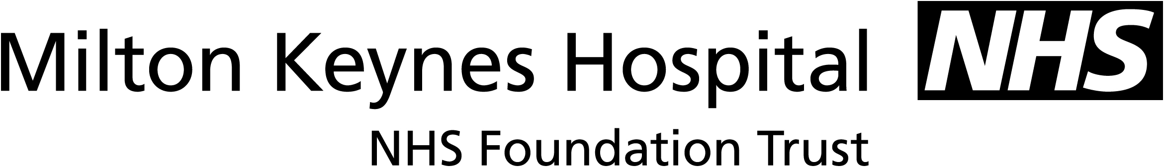

COLLECTION OF SPECIMENS
FOLLOWING SUDDEN DEATH IN CHILDHOOD

The specimens needed will vary depending on the age of the child and whether the child is on medication. The list below is appropriate for infant deaths but not for older children. For example in the older age group toxicology is important, in children with epilepsy anti-convulsant levels should be obtained so some thought is needed as to what should be done. Sometimes blood is impossible to obtain and the dignity of the deceased has to be considered but the “spots” are easy to obtain.

Blood Tests

1-2mls into gold topped tube for toxicology.

1ml into aerobic and anaerobic (if sufficient) blood culture bottles.

1-2ml into lithium heparin for cytogenetics (if baby dysmorphic).

2 “spots” on newborn blood screening card (always available on NNU) for metabolic disorders.

Cerebrospinal fluid.

Few drops only for microscopy, culture and sensitivity.

Nasopharyngeal aspirate.

Virology.

Culture and sensitivity.

Swabs.

Take from any identifiable lesion.

Urine.

Send any obtained for toxicology and inherited metabolic disease.

B.B. Blood and urine samples for toxicology will need to be spun down and stores at -20 celsius.

