

|  |  |  |
| --- | --- | --- |
| **Meeting title** | **Trust Board** | **Date: 02 November 2023** |
| **Report title:** | **Mortality Update** | **Agenda item: XX** |
| **Lead director**  **Report author**  **Sponsor(s)** | **Dr Ian Reckless**  **Dr Nikolaos Makris** | **Medical Director**  **Associate Medical Director** |
| **FoI status:** | **Publicly disclosable** |  |

|  |  |  |  |  |
| --- | --- | --- | --- | --- |
| **Report summary** | The Trust regards mortality as an important metric of the quality of the services provided. Hospital mortality may reflect the performance of the wider health and social care system in Milton Keynes. There is *quantitative* evidence to demonstrate that risk adjusted mortality at MKUH is ‘as expected’ when compared to peers. There are no major outlying areas of concern.  Deaths are also analysed *qualitatively* with 100% coverage through the Medical Examiner system, and the use of ‘Structured Judgement Reviews’ to ensure that there is learning in cases where it is felt that the outcome could have been improved. The statutory Coronial system is also involved in the review of selected hospital deaths and provides an additional layer of assurance.  The Trust’s system of mortality review is operated through the Mortality Review Group, reporting through to Patient Safety Board and on to Trust Executive Committee. | | | |
| **Purpose**  *(tick one box only)* | **Information**  **X** | **Approval** | **To note** | **Decision** |
| **Recommendation** | Receive and discuss | | | |

|  |  |
| --- | --- |
| **Report history** | Periodic updates |

**Executive Summary**

High-level *quantitative* metrics for the most recent 12-month rolling period available are as follows:

* The Trust’s **crude mortality rate is ‘first quartile'** when examined alongside its peers (1.13% compared to a national rate of 1.27%).
* The Trust’s **HSMR is statistically ‘mid-range’** when examined alongside its peers (rolling 12 months, to August 2023) (108.2 compared to 102.5).
* The Trust’s **SHMI is in the ‘as expected’ category** (rolling 12 months to May 2023) (1.03 compared to 100)
* The **In-hospital SHMI** is slightly below the national benchmark (70.4 compared to 75.6). This **remains in the ‘mid-range.**’

A variety of data definitions are included in **appendix 1**. The Trust has undertaken detailed work to better understand its position in relation to the risk-adjusted mortality indices (HSMR and SHMI), as some of the figures are numerically above the national average (although importantly within the expected range). Key factors from the review are:

* The frequency with which ‘signs or symptoms’ are coded as the primary diagnosis at MKUH has increased since the introduction of our Electronic Health Record (EHR). An inpatient admission is divided into a larger number of slides known as ‘finished consultant episodes’ (FCE). An FCE is the time spent under the care of a named consultant in a named specialty. Only information recorded in the initial two FCEs is considered in determining mortality statistics. A patient admitted with and dying from bilateral bronchopneumonia (a condition known to have a high mortality rate) may have their admission coded as the symptoms / signs of ‘cough and dyspnoea’ if the second FCE concludes before the necessary information is available to enable ‘bilateral bronchopneumonia’ to be recorded in the notes (and subsequently coded).
* While depth of coding (illustrated by Average Diagnoses per FCE) is in line with the national average, the proportion in hospital SHMI-spells with invalid or incomplete primary diagnoses is high amongst NHS Trusts (31.7%) These spells are mis-categorised into an incorrect diagnostic group, rendering them meaningless in the interpretation of mortality. The fact that a significant proportion of relevant hospital spells (almost a third) are not correctly risk adjusted may explain the disparity between the low crude mortality and the apparently high risk-adjusted mortality.

In relation to the *qualitative* review of deaths, MKUH has established a Medical Examiners’ Office (MEO) which:

* reviews all hospital deaths and is expanding its role to review community deaths
* issues Medical Certificates of Cause of Death (MCCD) in conjunction with the primary doctor;
* liaises with / refers to the Coroner’s Office; and,
* requests Structured Judgement Reviews (SJRs) from medical teams where potential concerns are raised by clinicians, family members or MEs.

The system is being expanded nationally to include review of all community deaths. This was initially anticipated to be complete by April 2023, but is now expected to become statutory in April 2024. The MEO is well placed to comply with this.

**Main Report:**

**Quantitative data relating to mortality**

Crude mortality data are shown in **Appendix 2a**.

HSMR data (supplied by CHKS) covering the period September 2022 – August 2023 are shown in **Appendices 2a and 2b**.

SHMI data (supplied by NHS Digital / CHKS) covering the period June 2022 – May 2023are shown in **Appendices 2a and 2c**.

Since last year’s Board Mortality Report, sepsis, both as a primary diagnosis, and as ‘any diagnosis’ during a hospital spell, has been added to the mortality dashboard (Appendix 2a.) This is in response to coronial concerns regarding the recognition of the deteriorating patient and treatment of sepsis. The Trust is in the ‘first quartile’ for sepsis as a primary diagnosis and ‘mid-range’ for sepsis as ‘any diagnosis.’ In addition, SJRs (see qualititative mortality review section), are requested in all patients where sepsis was the cause of or contributed to death.

Relevant contextual points in understanding the underlying data include:

* Palliative care coding was previously high compared to the national peer position but is now ‘mid-range.’ Work has previously been undertaken to demonstrate that the palliative care team only becomes involved in appropriate cases.
* Coding depth is in line with the peer position, with an average of 6.9 diagnoses per Finished Consultant Episode (FCE).
* Completeness of coding limits the accuracy and utility of risk-adjusted mortality indices. MKUH has a relatively high number of SHMI spells with an uncoded primary diagnosis amongst NHS Trusts. This results in large numbers of episodes being incorrectly risk adjusted, elevating the apparent values for SHMI. Discussions between NHS England and the clinical coding department are being arranged to understand and improve the picture. See **Appendix 3**
* ‘Sign or symptom’ coding (where signs or symptoms rather than an actual diagnosis are associated with the patient’s episode of care) is high compared to the peer position, with 10.7% of admissions having a sign or symptom as a primary diagnosis compared to the national average of 9.1%.
* Percentage of ‘zero-day length of stay admissions via the Emergency Department’ was historically low compared to peer but has moved through mid-range in the last year and is now high. This was initially a result of changes to the recording of attendances at the Ambulatory Emergency Care Unit (AECU), which previously gave artificially low values for MKUH. The opening of the Maple Unit and the Same Day Emergency Care ward are likely to have contributed to this change.

Subset analysis of HSMR or SHMI (based on the ‘56 diagnostic baskets’ making up HSMR, or 142 diagnostic groups making up SHMI) intermittently flags outlier status. Any outlier flags are reviewed and discussed at the Mortality Review Group (MRG). Current flags include pneumonia, fractured neck-of-femur and perinatal mortality. There are currently no flags that – following screening and analysis of individual patient records– lead the MRG to have cause of concern in respect of care quality.

**Perinatal Mortality**

The recording and review of stillbirths, late fetal losses and perinatal deaths in the Trust is carried out through the Perinatal Mortality Review Group (PMRG). This is a multi-disciplinary meeting consisting of Midwives, Obstetricians, Neonatologists and members of the Governance Team. It includes external reviewers alongside those from MKUH. Deaths are reported to the MBRRACE-UK perinatal mortality surveillance group in a standardised format (using the Perinatal Mortality Review Tool, PMRT).

Across Q2 (July to September 2023), there were five stillbirths (2.4 per 1000 births) and no neonatal deaths. One stillbirth has yet to be reviewed. The remaining four have been reviewed, with likely causes of death being given as: diabetes, chromosomal abnormalities, suspected placental abruption, and unknown.

PMRG examines the care received by the mothers from time of booking until delivery and assesses whether there were issues with care delivery and whether that may have made a difference to the outcome. In two of the four cases, issues were identified which may have influenced the outcome. These were: an earlier referral to foetal medicine and the initiation of aspirin in a mother who had previously delivered a small-for-gestational-age baby.

Learning from this group is collated into an action plan and disseminated via Clinical Governance Meetings, newsletters, teaching, and emails.

**Qualitative data relating to mortality**

Data from the Medical Examiners’ Office for the last 15 months are illustrated in the table below.

|  |  |  |  |  |  |
| --- | --- | --- | --- | --- | --- |
|  | **Q2**  **Jul-Sep**  **2022** | **Q3**  **Oct-Dec 2022** | **Q4 Jan-Mar 2023** | **Q1 Apr-Jun 2023** | **Q2 Jul-Sep 2023** |
| **Number of deaths** | 269 | 349 | 266 | 230 | 222 |
| **Number of deaths reviewed by Medical Examiner** | 100% | 100% | 100% | 100% | 100% |
| **Number of SJRs Requested by Medical Examiner** | 28 | 25 | 28 | 28 | 38 |
| **% Deaths in which SJR requested** | 10.4% | 7.2% | 10.5% | 12.2% | 17.1% |
| **Cases taken for investigation by the coroner following referral (% of total deaths)** | 14.4% | 15.5% | 10.9% | 9.1% | 13.9% |
| **Cases in which MCCD (Form A) completed after discussion with Coroner (% of total deaths)** | 8.9% | 12.9% | 9.4% | 12.6% | 15.3% |
| **% (Number) of Urgent Release completed paperwork within 24hours †** | 83%  (5/6) | 100% (2/2) | 100% (2/2) | 100% (4/4) | 100%  (5/5) |
| **MCCD completion within 3 days** | 97% | 91.4% | 91.0% | 91.3% | 90.1% |
| **Number of Relatives directed to PALS** | 7 | 13 | 8 | 8 | 11 |
| **Number of MCCDs rejected after Medical Examiner scrutiny** | 4 | 18 | 8 | 4 | 3 |
| **Deaths of people with Mental Health or Learning Disability diagnoses** | 4 | 0 | 0 | 1 | 0 |

All deaths in the Trust undergo review through the Medical Examiner system. Additional external review takes place for deaths accepted by the coroner for further investigation, paediatric deaths, perinatal deaths and deaths in patients with learning difficulties.

The ME system offers an objective review of the care delivered during the last hospital admission and is a point of contact for bereaved families or clinical teams to raise concerns about care prior to the death. Issues with care can also be highlighted by the Medical Examiner.

Deaths where concerns are raised regarding care undergo a formal Structured Judgement Review (SJR). SJRs are requested in all surgical deaths, a random selection of medical deaths, learning disability deaths, where sepsis is a cause of death, and in diagnoses where there is an HSMR alert.

SJRs are carried out by trained reviewers who look at the medical records in a critical manner and comment on specified phases of care. The output of the SJR is discussed at Mortality and Morbidity (M&M) Meetings. If a death is deemed potentially avoidable, or overall care delivery is rated as poor, then a second SJR is carried out at which point the case will be graded with an ‘avoidability’ score. The second SJR form should conclude with key learning messages from the case and actions to be taken.

In SJRs where concerns have been raised by family members, communication, either between teams or with the family, is the area most frequently highlighted by reviewers as requiring improvement.

A key area for development in the Trust’s mortality review framework is gathering and collating evidence from this qualitative review work – both within the Medical Examiner’s Office and in each clinical department which hosts M&M meetings and undertakes SJRs – to ensure that key themes are identified, and learning is shared and acted upon.

The web interface commissioned last year by the Trust to collate this information and allow near real-time tracking and review has now been completed. This allows the audit and comparison of SJR completion and outcomes from across the Trust, sharing of learning and coordination of quality improvement projects as part of the Patient Safety Investigation Response Framework (PSIRF.)

Divisional patient safety leads will provide quarterly updates to MRG on completion and outcomes of SJRs within their divisions and share key learning from M+M teams across patient safety teams.

The next iteration of this dashboard, currently in development, will allow the user to customise searches to whatever query they wish to answer in response to new questions or challenges with mortality data.

**Appendix 1**

**Definitions**

**Crude Mortality –** A hospital’s crude mortality rate looks at the number of deaths that occur in a hospital in any given year and expresses this as a proportion of the number of people admitted for care in that hospital over the same period. The crude mortality rate can then be articulated as the number of deaths for every 100 patients admitted.

**Finished Consultant Episode (FCE)** **–** A continuous period of admitted patient care under one consultant within one healthcare provider**.**

**HSMR –** Hospital Standardised Mortality Rate (HSMR). This measure only includes deaths within hospital for a restricted group of 56 diagnostic categories with high numbers of admissions nationally. It takes no account of the death of patients discharged to hospice care or to die at home. The HSMR algorithm involves adjustments being made to crude mortality rates to recognise different levels of comorbidity and ill-health for patients cared by similar hospitals. HSMR was created by Dr Foster (now Telstra Health).

**MBRRACE –** Mothers and Babies, Reducing Risk through Audits and Confidential Enquiries. A national confidential enquiry collecting data on deaths in pregnant women (up to one year post-partum) and perinatal deaths from 22 weeks gestation up to 28 days post delivery.

**Relative Risk** – Measures the actual (observed) number of deaths against the expected number deaths. Both the SHMI and the HSMR use the ratio of actual deaths to an expected number of deaths as their statistic. HSMR multiplies the Relative Risk by 100. SHMI is typically presented around a mean expressed as 1.00.

* HSMR above 100 / SHMI above 1.00 = There are numerically more deaths than expected
* HSMR below 100 / SHMI below 1.00 = There are numerically less deaths than expected

Confidence intervals are then described suggesting the likelihood that any variation between observed and expected has occurred through chance alone or represents a ‘statistically significant’ variation (real, not due to chance).

**Structured Judgement Review (SJR)** –A report created according to a standard template, reviewing the care given to a deceased patient which generates a score for the quality of care given.

**SHMI** – Summary Hospital-level Mortality Indicator (SHMI). SHMI indicates the ratio between the actual number of patients who die following treatment at the Trust and the number that would be expected to die based on average England figures, given the characteristics of the patients treated. It includes deaths which occur in hospital and deaths which occur outside of hospital within 30 days (inclusive) of discharge.

**CHKS**. Third-party tools are used to report the relative position of Milton Keynes University Hospital NHS Foundation Trust (MKUH) on nationally published mortality statistics. CHKS produces monthly mortality reports for MKUH based on its Hospital Episode Statistics (HES) data submissions.

**Appendix 2a**

**Summary Mortality Data**

|  |  |  |  |  |  |  |
| --- | --- | --- | --- | --- | --- | --- |
| Metric | Period | **Previous** | **Latest** | **National Peer** | **Variance** | ***Status*** |
| HSMR | R12M to Aug-23 | 109.3 | 108.2 | 102.5 | 6.8 | 'Mid range' |
| SHMI | R12M to May-23 | 104.0 | 103.5 | 100.0 | 4.1 | 'As expected' |
| SHMI - In Hospital | R12M to Aug-23 | 72.1 | 70.4 | 75.6 | -3.5 | 'Mid range' |
| Mortality Rate % | R12M to Aug-23 | 1.15 | 1.13 | 1.27 | -0.12 | 'First Quartile' |
|  |  |  |  |  |  |  |
| Sepsis: In Hospital Mortality - primary diagnosis | R12M to Aug-23 | 15.3% | 15.4% | 19.1% | -3.8% | 'First Quartile' |
| Sepsis: In Hospital Mortality - any diagnosis | R12M to Aug-23 | 22.9% | 22.9% | 21.7% | 1.1% | 'Mid range' |
|  |  |  |  |  |  |  |
| FCEs with palliative care code Z515 | R12M to Aug-23 | 1.60% | 1.6% | 1.4% | 0.2% | 'Mid range' |
| Deaths with palliative care code Z515 | R12M to Aug-23 | 46.76% | 46.2% | 41.2% | 5.0% | Mid range' |
| Average Diagnoses per FCE | R12M to Aug-23 | 7.3 | 7.3 | 6.9 | 0.4 | Mid range' |
| Sign or symptom as a primary diagnosis | R12M to Aug-23 | 11% | 10.7% | 9.1% | 1.6% | Mid range' |
| % 0 Length of Stay Admissions via A&E | R12M to Aug-23 | 39.19% | 41.4% | 31.4% | 10.0% | 'Fourth Quartile' |
| Readmissions within 30 days | R12M to Aug-23 | 10.15% | 10.4% | 8.4% | 2.0% | 'Fourth Quartile' |

**Appendix 2b**

**HSMR**

|  |  |  |  |  |  |  |  |  |  |  |  |  |
| --- | --- | --- | --- | --- | --- | --- | --- | --- | --- | --- | --- | --- |
| **HSMR** | **Sep-22** | **Oct-22** | **Nov-22** | **Dec-22** | **Jan-23** | **Feb-23** | **Mar-23** | **Apr-23** | **May-23** | **Jun-23** | **Jul- 23** | **Aug-23** |
| Trust Monthly | 113.5 | 115.3 | 110.0 | 122.8 | 93.4 | 104.4 | 100.0 | 91.1 | 131.2 | 110.6 | 100.2 | 0.0 |
| Trust 12 month rolling | 113.3 | 113.5 | 113.8 | 114.5 | 113.0 | 112.2 | 111.5 | 109.2 | 112.1 | 112.2 | 109.3 | 108.2 |
| National Peer 12 month rolling | 104.3 | 104.7 | 104.6 | 105.8 | 105.4 | 105.4 | 105.4 | 105.2 | 104.9 | 104.4 | 103.1 | 102.5 |
| Variance from the national peer | 9.0 | 8.8 | 9.2 | 8.7 | 7.6 | 6.8 | 6.0 | 4.0 | 7.2 | 7.7 | 6.2 | 5.7 |

Table showing the last 12 months value for MKUH HSMR and rolling 12-month HSMR average in comparison to National Peer values.

**HSMR, monthly**

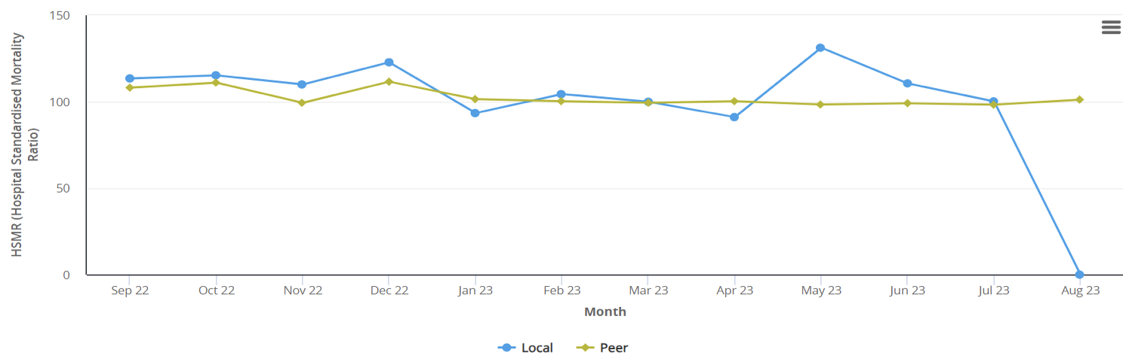

Line graph showing MKUH HSMR (blue) broadly tracking the national peer average. The August value is zero due to insufficient coding for that month.

**HSMR, national peer comparison**

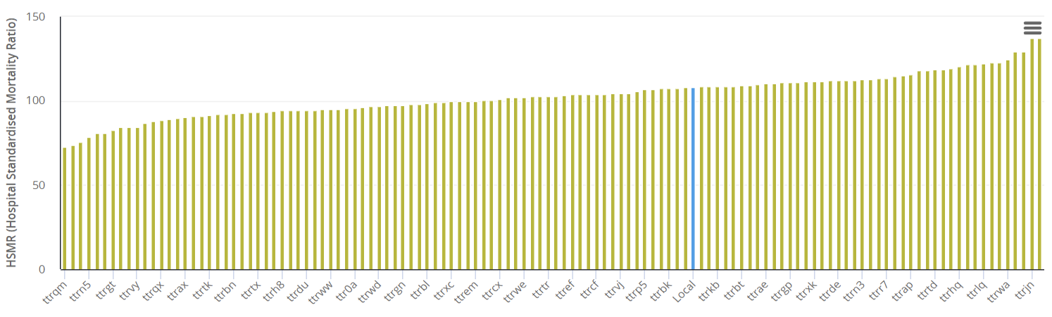

Bar graph showing MKUH HSMR (blue) in comparison to other Trusts.

**Appendix 2c**

**SHMI**

|  |  |  |  |  |  |  |  |  |  |  |  |  |
| --- | --- | --- | --- | --- | --- | --- | --- | --- | --- | --- | --- | --- |
| **SHMI** | **Jun-22** | **Jul- 22** | **Aug-22** | **Sep-22** | **Oct-22** | **Nov-22** | **Dec-22** | **Jan-23** | **Feb-23** | **Mar-23** | **Apr-23** | **May-23** |
| Trust Monthly | 104.6 | 116.7 | 104.2 | 128.7 | 119.9 | 115.7 | 109.8 | 90.0 | 81.6 | 87.6 | 94.6 | 99.4 |
| Trust 12 month rolling | 106.0 | 105.4 | 105.2 | 107.5 | 109.6 | 109.3 | 110.5 | 108.5 | 107.5 | 106.2 | 103.8 | 103.5 |
| National Peer 12 month rolling | 100.4 | 100.7 | 100.6 | 100.5 | 100.4 | 100.1 | 101.1 | 101.1 | 101.0 | 100.6 | 100.3 | 100.0 |
| Variance from the national peer | 5.6 | 4.6 | 4.6 | 6.9 | 9.2 | 9.1 | 9.5 | 7.5 | 6.5 | 5.6 | 3.5 | 3.6 |

**SHMI, monthly**

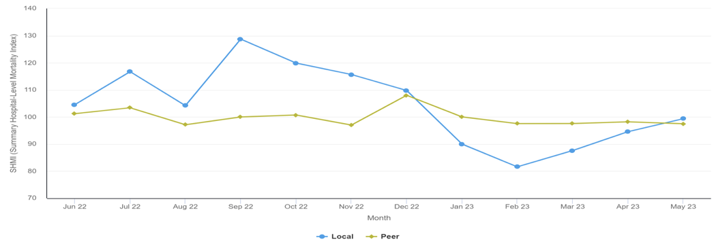

Line graph showing MKUH SHMI monthly (blue) in comparison to the National Peer.

**SHMI, National peer comparison**

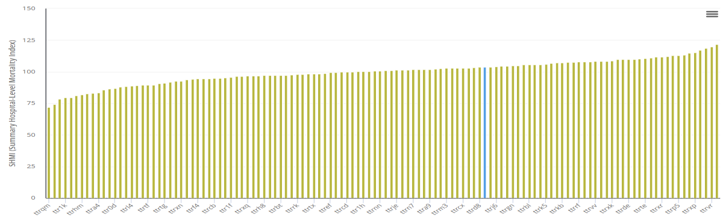

Bar chart showing MKUH SHMI position (blue) in relation to other NHS Trusts.

**Appendix 3**

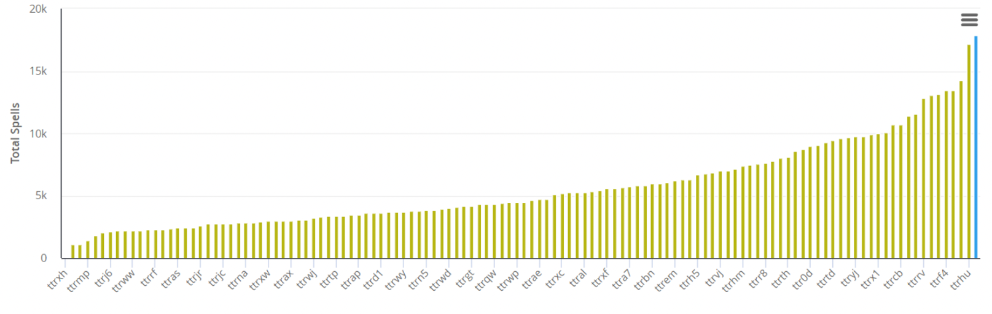

Bar chart showing MKUH uncoded primary diagnosis spells (blue) for the period June 2022-May 2023 in comparison to other Trusts. There are 17876 spells (or 31.8% of HES spells eligible for SHMI analysis) without a valid primary diagnosis. These include 48 deaths.

The invalid spells are placed in ‘Diagnostic Basket 140’ rendering them valueless for calculating indexed mortality. With such a large proportion of uncoded spells, the calculated SHMI value should be treated with caution. This data has been validated by NHS England, which provides SHMI calculations but there is no reason to suspect that it does not apply equally to HSMR spells.

Improvement of coding of primary diagnosis will be critical in improving the accuracy and utility of MKUH’s indexed mortality data.