Guideline

Title: Insulin management guide for healthcare professionals
Classification: | Guideline
Authors Name: | Inpatient Diabetes Team
Authors Job Title: | Melanie Kennedy  Lead DSN/Diabetes Inpatient Specialist Nurse
Authors Division: | Medicine
Departments/ Groups this  Document Applies to: | Adult inpatients on medical/surgical wards
Date of Approval: | August 2023 | Review Date: | August 2025
Approval Group: | TEC | Last Review:

Unique Identifier: | Status: |  |  | Version No:
Scope: |  |  | Document for Public Display: No
To be read in conjunction with the following documents:
CPOC (December 2022) Guideline for peri-operative care for people with diabetes undergoing elective and emergency surgery
JBDS-IP (March 2023) The management of Diabetic Ketoacidosis in Adults
JBDS-IP (February 2022) The Management of Hyperosmolar Hyperglycaemic State (HHS) in Adults
JBDS-IP (January 2023) The hospital management of Hypoglycaemia in Adults with Diabetes Mellitus
Diabetes Diagnostic Aid Diabetes-Diagnostic-Aid.pdf (mkuh.nhs.uk)
Variable rate insulin infusion Trust Documentation Site - Variable rate Intravenous insulin infusion (VRiii).pdf - All Documents (sharepoint.com)

Required CQC (Care Quality Commission) evidence? |  | Key CQC Question:  Safe/Effective/Responsive/Caring

Disclaimer –
Since every patient's history is different, and even the most exhaustive sources of information cannot cover every possible eventuality, you should be aware that all information is provided in this document on the basis that the healthcare professionals responsible for patient care will retain full and sole responsibility for decisions relating to patient care; the document is intended to supplement, not substitute for, the expertise and judgment of physicians, pharmacists or other healthcare professionals and should not be taken as an indication of suitability of a particular treatment for a particular individual.

The ultimate responsibility for the use of the guideline, dosage of drugs and correct following of instructions as well as the interpretation of the published material lies solely with you as the medical practitioner.

Index
Guideline Statement 2
Executive Summary 2
1.0 Roles and Responsibilities: 2
2.0 Implementation and dissemination of document 2
  - Processes and procedures 3
  - ….. 3
  - . 3
  - . 3
  - . 4
4.0 Statement of evidence/references 7
  - Governance 7
  - Record of changes to document 7
  - Consultation History 7
  - Audit and monitoring 8
  - Equality Impact Assessment 8

Guideline Statement
This guideline is to support clinicians to safely manage hyperglycaemia, rule out diabetes emergencies (DKA/HHS) and guide the titration of insulin doses for adult inpatients at MKUH (Milton Keynes University Hospital).

For the following areas please also refer to the relevant guidelines on Trust Documentation or DiAPPbetes.
- For dose adjustment of insulin prior to surgical procedures, (CPOC guideline)
- For patients with hyperglycemia secondary to steroid use or Covid positive patients requiring dexamethasone treatment
- For patients requiring Variable rate insulin infusion (VRiii). Please use the PowerPlan on eCARE
- Patients requiring DKA (Diabetic Ketoacidosis), or HHS (Hyperosmolar Hyperglycaemic State) management please use the PowerPlan on eCARE.

Executive Summary

This guideline seeks to support clinical decision making in patients experiencing hyperglycaemia by helping to rule out diabetes emergencies such as DKA/HHS, guiding ‘correction doses’ of insulin and titrating the patient's own insulin regimen to prevent complications of hyperglycaemia for adult patients with diabetes on medical and surgical wards.

Roles and Responsibilities:

If there is uncertainty after reviewing this guideline you must escalate concerns to a senior member of your team or the Diabetes MDT (Multi-Disciplinary Team).

All Healthcare professionals who prescribe, dispense and/or administer insulin must complete the mandatory insulin safety module on ESR (Electronic Staff Record)

The DISN Team work Monday to Friday 8-4pm. Saturday and Sunday 8-12:15. No bank holidays.

2.0 Implementation and dissemination of document

The guideline will be added to Trust Documentation and the DiAPPbetes page. It will be communicated via the weekly newsletter and a laminated chart sent to all wards by the DISN team.

Abbreviations
BNF – British National Formulary
CBG – Capillary Blood Glucose
CIG – Clinical Improvement Group
CPOC – Centre for Perioperative Care
CSii – Continuous Subcutaneous Insulin Infusion pump
DAFNE – Dose Adjustment For Normal Eating
DKA – Diabetic Ketoacidosis
DISN – Diabetes Inpatient Specialist Nurse
ESR – Electronic Staff Record
FRiii – Fixed rate intravenous insulin infusion
HHS – Hyperosmolar Hyperglycaemic State
MDT – Multi-Disciplinary Team
PRN – Pro rate nata
SGLT2i – Sodium-glucose Transport Protein 2
T1DM – Type 1 Diabetes Miletus
VBG – Venous Blood Glucose
VRiii – Variable Rate Intravenous Insulin Infusion

The guidelines will be available on the Trust intranet and in the departmental guidelines folder for easy access.

Processes and procedures

Management of Hyperglycaemia- High Capillary Blood Glucose (CBG) Levels in Adult inpatients with Diabetes

Standard capillary blood glucose (CBG) target for inpatients with diabetes is 6-10mmol/L (4-12mmol/L is acceptable)
Conservative CBG target for frail patients 6-15mmol/L and patients at end of life <20mmol/L (please see End of Life care diabetes guideline)
If capillary blood glucose is above individualised target, review patient and CBG readings for the last 48 hours (if available). Check CBG pre-meal and bedtime (10pm) as minimum.
Check for ketones (capillary) in ANY patient known to have diabetes who is clinically unwell or in patients who are clinically well if CBG >18mmol/l (have a lower threshold for checking ketones in patients with T1DM, patients taking SGLT2i medications or are symptomatic of ketoacidosis)

For patients without a pre-existing diagnosis of diabetes refer to the Diagnostic Aid on Diappbetes (DIAPPBETES - Milton Keynes University Hospital (mkuh.nhs.uk) or Trust Documentation

Look for the cause – consider dehydration, inter-current illness, sepsis, missed/incorrect dose of oral hypoglycaemic agents or insulin/steroids/NG feeds.

Doctors are to review the patient and advise treatment according to flowcharts/guidance below.

All insulin adjustments are usually made by increasing or decreasing the dose by 10-20% dependent on severity of hyper/hypoglycaemia.

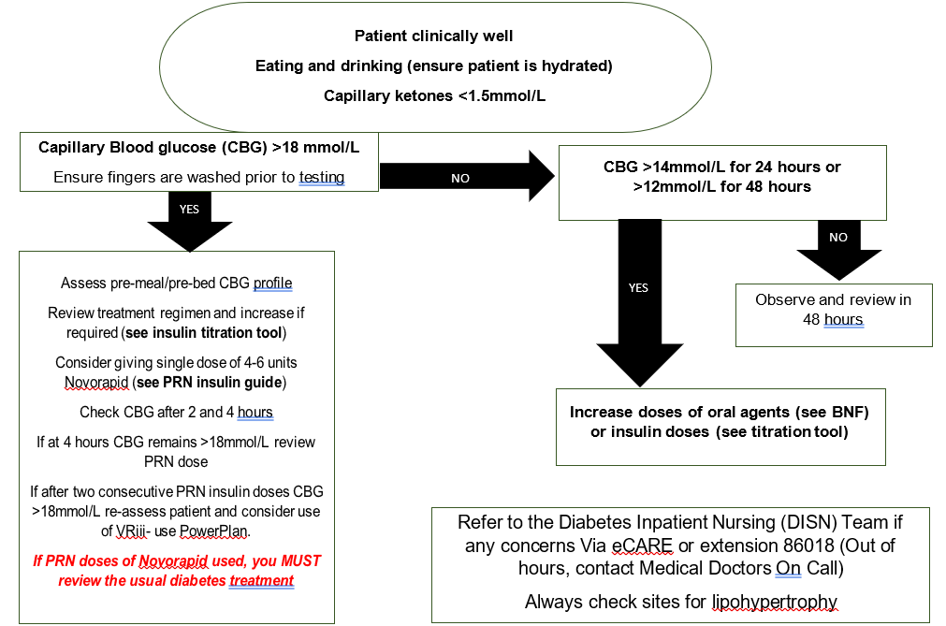

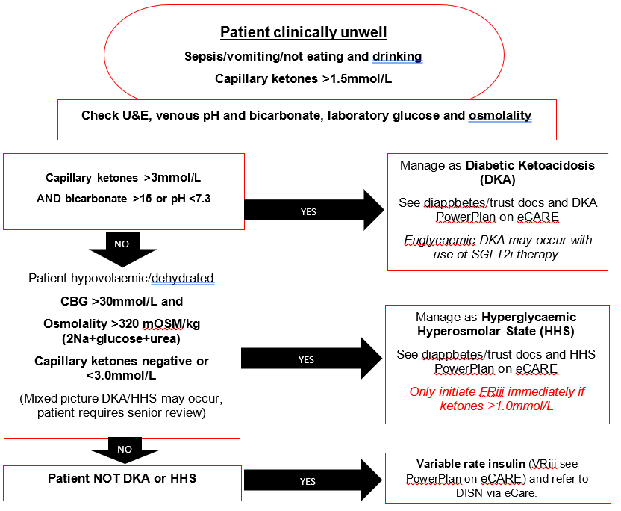

PRN Insulin dose guidance for patients with CBG >18mmol/L

- Standard CBG target for inpatients with diabetes is 6-10mmol/L (4-12mmol/L acceptable)
- Conservative CBG target for frail patients 6-15mmol/L and patients at end of life <20mmol/L (see End of life guideline)
- Guidance for PRN insulin doses given in table (right)
- For patients with conservative target range consider reducing PRN insulin dose to avoid hypoglycaemia

NOTE/CAUTION: As a guide 1 unit of Novorapid will reduce CBG by 2-3mmol/L
Some patients with T1DM, particularly if slim, newly diagnosed (see diagnostic aid) or on very small amounts of regular insulin, can be very sensitive to insulin. Review PRN insulin doses in context of their usual insulin doses and usual correction doses (if known)
Prescribe Novorapid PRN 4-6 units via subcutaneous route at maximum frequency of 4 hourly on ECARE.
Nursing staff: Document actual dose given on ECARE, check CBG at 2 and 4 hours. Check capillary ketones if CBG >18mmol/L (lower threshold for checking in patients with T1DM and if symptoms of ketoacidosis)

CBG (mmol/L)
PRN Insulin dose
18.1-25
4 Units
>25.1
6 Units
If no PRN doses required in 48-hour period STOP PRN Novorapid Insulin
If >1 PRN doses given in 24-hour period continue PRN Novorapid insulin and review daily
If multiple daily PRN doses of Novorapid given
Review usual insulin (see titration tool) and other diabetes medication (BNF)
Refer to DISN team via eCARE or extension 86018
Do not discharge patients with PRN Novorapid unless patient has received education

Insulin dose titration tool for adult in-patients with diabetes
Purpose
- To provide a clear approach to safely titrating insulin doses for all adult inpatients admitted to medical and surgical wards at MKUH.

Before titrating insulin:
- Do not act on a single CBG reading. Review the glucose profile of the last 48 hours before making a change. CBG outside of target should be monitored pre-meal and pre-bed (10pm).
- Ensure the insulin has been given at the correct times. For example: quick acting or biphasic insulins being given 10 minutes before or with meals.
- Check the patient’s injection sites for signs of lipohypertrophy (lumps or hardened areas of skin at the injection sites) - this will affect the absorption of insulin and can result in variable blood glucose levels. If lipos are present, insulin may need to be reduced by at least 20% before using a fresh site.

Hypoglycaemia episodes (CBG <4mmol/L regardless of symptoms) must be treated according to Trust guidance and documented using /diaHypo. See DIAPPBETES - Milton Keynes University Hospital (mkuh.nhs.uk)
If staff are unsure regarding safe titration of insulin despite referral to the guidance, then they should seek advice from the specialist diabetes team or a senior colleague. Please complete the annual insulin safety module on ESR if you have not done so.
The Diabetes Inpatient Specialist Nurse (DISN) team can be contacted Mon-Fri 8am-4pm, Saturday and Sunday 8-12:15pm, No bank holidays. All referrals should be sent via eCARE. Telephone advice on 86018. For patients using CSii (Continuous Subcutaneous Insulin Infusion pump) please read ‘managing patients on pumps’ document on DiAPPbetes and refer to the DISN team for further advice and support. Follow up for young adults, pregnant patients with pre-existing diabetes or Insulin pump users please refer to TDSNT@mkuh.nks.uk

Basal Bolus Insulin Regimen

Quick acting insulin with meal
(Novorapid/Humalog/Apidra/Fiasp/Actrapid/Humulin s)
Once or twice daily basal/background insulin
(Lantus/Levemir/Tresiba/Toujeo/Abasaglar/Humulin I/Insulatard)
If the patient is carbohydrate counting e.g., DAFNE trained and competent to self-manage their diabetes, allow them to self-adjust their doses
If patient is on fixed subcutaneous doses, follow flowchart below
Hyperglycaemia pre-breakfast
Hyperglycaemia pre-lunch/dinner or pre- bed
Hypoglycaemia pre-breakfast
Hypoglycaemia pre-lunch/dinner or pre-bed
Increase bedtime basal insulin by 10-20% ensuring no more than 2mmol/L overnight drop in CBG
Increase the preceding mealtime insulin by 10-20%
Reduce the bedtime basal insulin by 10-20% depending on severity of hypo event
Reduce the preceding mealtime insulin by 10-20%

Twice Daily Biphasic (pre-mixed) Insulin Regimen

Twice daily (sometimes three times daily) MEALTIME injections
Novomix 30, Humalog Mix 25 or 50, Humulin M3
(Number refers to percentage amount of quick acting insulin in each injection)
If patient self manages at home and is able to do so, let them adjust own doses. If on fixed doses, follow flowchart below
Hyperglycaemia pre-bed AND pre-breakfast
Hyperglycaemia pre-lunch/pre-evening meal
Hypoglycaemia overnight/ prebreakfast
Hypoglycaemia pre-lunch/pre-evening meal
Increase evening Insulin by 10-20% ensuring no more than 2mmol/L drop in CBG overnight
Increase morning insulin by 10-20%
Reduce evening insulin dose by 10-20% depending on severity of hypo event
Reduce breakfast insulin dose by 10-20% (or preceding dose if on TDS dosing)

Once or Twice Daily Basal Insulin Regimen

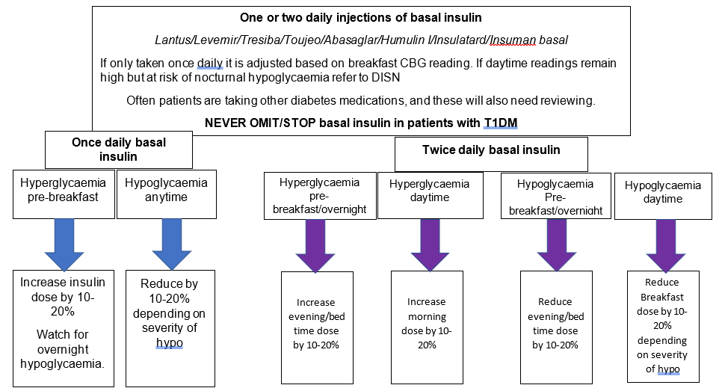

Sepsis, reduced mobility, stress, steroids, and supplementary feeding can all have an effect and may increase blood glucose levels.
For patients who are clinically unwell refer initially to the Hyperglycaemia Decision support tool and ensure DKA/HHS excluded.

Once the patient is well, doses may need reducing back to their pre-admission doses to prevent hypoglycaemia at home.

Ensure medication has been given as prescribed and the patient is compliant with the regimen
Ensure the correct insulin is being administered at the correct time. Insulin is a time-critical medication
Remember the 6 R’s
- Right person
- Right Insulin
- Right time
- Right place
- Right dose
- Right device
Exclude any mechanical issues with the insulin pen device. Has it been stored correctly? If in doubt discard the pen and start a new one.
Label the insulin pen for individual use
Biphasic/Isophane insulins are cloudy, these need gently mixing using a rock and roll method.

Never draw insulin from a pen device and if using a vial always use an insulin syringe, otherwise this can result in an insulin overdose.

4.0 Statement of evidence/references

Tables adapted from UHL Hyperglycaemia in adult inpatients Diabetes decision tool and insulin dose titration guide for adult inpatients.
ABCD DTN-UK (2018) Clinical Guideline: Guidelines for managing continuous subcutaneous insulin infusion (CSII, or ‘insulin pump’) therapy in hospitalised patients [Online] Available from: https://abcd.care/sites/abcd.care/files/CSII_DTN_FINAL%20210218.pdf (Accessed 10 March 2023)
Alam U (2022) Type 2 Diabetes Mellitus Management in Older Adults [Online] Available from: https://www.clinicalkey.com/#!/content/clinical_overview/67-s2.0-v1009 (Accessed 10 March 2023)
Cheisson G, et al (2018) Perioperative management of adult diabetic patients. Intraoperative period, Anaesthesia Critical Care & Pain Medicine, Volume 37, Supplement 1, June 2018, Pages S21-S25 [Online] Available from: https://www.sciencedirect.com/science/article/pii/S2352556817302965 (Accessed 10 March 2023)
CPOC (December 2022) Guideline for peri-operative care for people with diabetes undergoing elective and emergency surgery [Online] Available from: https://cpoc.org.uk/sites/cpoc/files/documents/2023-02/CPOC-Diabetes-Guideline-Updated2022_0.pdf (Accessed 10 March 2023)
Elsevier Point of Care (2023) Diabetes Mellitus Type 1 in Adults [Online] Available from: https://www.clinicalkey.com/#!/content/clinical_overview/67-s2.0-66fa155b-2e72-4cb6-87eb-b1f0b20002bb (Accessed 10 March 2023)
Elsevier Point of Care (2022) Diabetes Mellitus Type 2 in Adults [Online] Available from: https://www.clinicalkey.com/#!/content/clinical_overview/67-s2.0-52bcd52e-425c-4167-ae97-d1f5f7238eeb (Accessed 10 March 2023)
Holt RIG, et al (2021) The Management of Type 1 Diabetes in Adults. A Consensus Report by the American Diabetes Association (ADA) and the European Association for the Study of Diabetes (EASD), Diabetes Care, 2021;44(11):2589–2625 [Online] Available from: https://diabetesjournals.org/care/article/44/11/2589/138492/The-Management-of-Type-1-Diabetes-in-Adults-A (Accessed 10 March 2023)
Inpatient Diabetes Training and Support (2019) Insulin and Insulin Safety [Online] Available from: https://www.inpatientdiabetes.org.uk/insulin-and-insulin-safety (Accessed 28 March 2023) JBDS-IP (March 2023)
The management of Diabetic Ketoacidosis in Adults [Online] Available from: https://abcd.care/sites/abcd.care/files/site_uploads/JBDS_Guidelines_Current/JBDS_02_DKA_Guideline_March_2023.pdf (Accessed 10 March 2023) JBDS-IP (February 2022)
The Management of Hyperosmolar Hyperglycaemic State (HHS) in Adults [Online] Available from: https://abcd.care/sites/abcd.care/files/site_uploads/JBDS_Guidelines_Current/JBDS_06_
The_Management_of_Hyperosmolar_Hyperglycaemic_State_HHS_%20in_Adults_FINAL_0.pdf (Accessed 10 March 2023) JBDS-IP (January 2023) The hospital management of Hypoglycaemia in Adults with Diabetes Mellitus [Online] Available from: https://abcd.care/sites/abcd.care/files/site_uploads/JBDS_Guidelines_Current/JBDS_01_Hypo_Guideline_January_2023.pdf (Accessed 10 March 2023)
Milton Keynes University Hospital NHS Foundation Trust (2021) DIAPPETES [Online] Available from: https://www.mkuh.nhs.uk/diappbetes (Accessed 10 March 2023) National Institute for Health and Care Excellence (2015, updated 2022)
Type 1 diabetes in adults: diagnosis and management. NICE guideline [NG17] [Online] Available from: https://www.nice.org.uk/guidance/ng17 (Accessed 10 March 2023) National Institute for Health and Care Excellence (2015, updated 2022)
Type 2 diabetes in adults: management. NICE guideline [NG28] [Online] Available from: https://www.nice.org.uk/guidance/ng28 (Accessed 10 March 2023)
Trend Diabetes (2022) Injection technique matters [Online] Available from: https://trenddiabetes.online/injection-technique-matters (Accessed 10 March 2023)

Governance

Record of changes to document
Version number: |  |  | Date:
Section Number | Amendment | Deletion |  | Addition | Reason

Consultation History
Stakeholders Name/Board | Area of Expertise | Date Sent | Date Received | Comments | Endorsed Yes/No
TEC |  | 5/5/23 |  | Will be noted at next TEC meeting, but advised document can be used.
TDC |  | 26/3/23 | 20/4/23 | Minor amendments | Yes
Tina Worth | Clinical Governance | 6/2/23 | 7/2/23 | Formatting changes | Yes
Pharmacy CIG | Pharmacy | 27/03/23 | 24/5/23 | Wording PowerPlan, clinical groups included, | Yes
Library | References | 13/4/23 | 28/04/23 |  | Yes
Internal CIG |  | 24/3/23 | 24/3/23 | Approved. Send to Pharmacy CIG, TDC and library | Yes
Diabetes consultants  Dr A Humayun  Dr A Ali  Dr S Chandran | Diabetes | 29/6/21 | 29/6/21 | Adjustments to wording on titration of Biphasic insulin  Font and colour of tables. Typos  Title | Yes
DISN team  K Hodgson  S Franklin  J Alin | Diabetes Inpatient care | June 2021 | June 2021 | Wording with CBG-adjusted | Yes
Pharmacy  J Corbett | Pharmacy program manager | 20/5/22 | 7/9/22 | Spelling. Clarifying instructions.  Guidance over titration.  Sites/lipos
Junior doctor | Inpatient care | 14/10/22 | 29/11/22 | Found it helpful. | Yes

Audit and monitoring
Audit/Monitoring Criteria | Tool | Audit Lead | Frequency of Audit | Responsible Committee/Board
Reviewed at CIG (Clinical Improvement Group) |  | Diabetes inpatient MDT | 2 yearly | Internal medicine CIG

Equality Impact Assessment
This document has been assessed using the Trust’s Equality Impact Assessment Screening Tool. No detailed action plan is required. Any ad-hoc incident which highlights a potential problem will be addressed by the monitoring committee.

Equality Impact Assessment
Division |  | Medicine |  |  |  |  | Department |  | Diabetes
Person completing the EqIA |  | M Kennedy |  |  |  |  | Contact No. |  | 86018
Others involved: |  |  |  |  |  |  | Date of assessment: |  | 17/2/2023
Existing policy/service |  | Yes |  |  |  |  | New policy/service |  | No
Will patients, carers, the public or staff be affected by the policy/service? |  |  |  | Yes
If staff, how many/which groups will be affected? |  |  |  | Doctors, nurses, pharmacists
Protected characteristic |  |  | Any impact? |  |  | Comments
Age |  |  | N
Disability |  |  | N
Gender reassignment |  |  | N
Marriage and civil partnership |  |  | N
Pregnancy and maternity |  |  | N
Race |  |  | N
Religion or belief |  |  | N
Sex |  |  | N
Sexual orientation |  |  | N
What consultation method(s) have you carried out?
For example: focus groups, face-to-face meetings, PRG, etc.
How are the changes/amendments to the policies/services communicated?
For example: email, meetings, intranet post, etc
What future actions need to be taken to overcome any barriers or discrimination?
What? | Who will lead this? |  |  |  | Date of completion |  |  | Resources needed
Review date of EqIA groups

